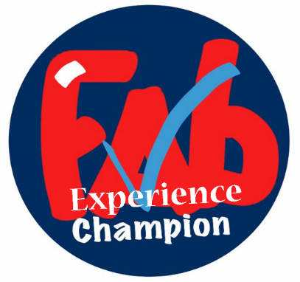
Awards Scheme
Bronze award
 | Evidence | Date | Champion signature | Line Manager signature
- Set up ward/department patient experience folder

- Create a patient experience display board – FFT, Care Opinion, Compliments

Friends and Family Test

- Register on FFT Envoy dashboard, download monthly service reports, received FFT alerts when patients do not recommend
- Monthly You Said We did poster clearly displayed and current
- FFT data is visibly displayed each month

Care Opinion

- Sign up to receive alerts

- Care Opinion webinar bite size sessions undertaken:

  - How to generate stories
  - How to respond and demonstrate impact
  - How to generate reports and visualisations
  - Promote Care Opinion to patients and visitors

- Respond to 4 stories relevant to your local ward/department
Academy of FAB Stuff

- Sign up and received newsletters

PALS & Complaints

- Understanding of key themes within the department/division
- Frequently interrogate data in SUPERB dashboard
Counting Compliments

- Routinely collect & submit Counting Compliments data

Carers

- Sign ward/department up to Every-One’s Carers Quality Award (its not just for clinical areas)

- Develop a patient experience action plan with collaboration with your colleagues using FFT, PALS, complaints and patient surveys (national & local)

Date of Patient Experience Team to review evidence:

Signed

Outcome:
Silver award

- Organise a local patient experience quality improvement/initiative based on feedback received

- Quality Improvement programme – complete the programme
Date of Patient Experience Team to review evidence:

Signed

Outcome:

Gold Award
Shout loud and proud about the project……..
- Present it to Patient Experience Group and/or Trust Board

- Share QI project on the Academy of FAB Stuff

- Write a blog?

- Organise a local patient experience quality improvement/initiative based on feedback received

- Achieve Every-One’s Carers Quality Award accreditation

Date of Patient Experience Team to review evidence:

Signed

Outcome:

