Case Study: Encouraging Potential Retirees to Stay

Background
Retirement is a significant issue for the NHS. NELFT had 1,666 employees age 53 and over, in February 2017 and in that year 137 employees retired. However, there is no retirement age and staff can continue to work in any capacity, as long as they feel able to in terms of their health and ability under the Equality Act 2010. The Trust was concerned that staff were retiring blindly; getting to when they can access pension savings and making the leap without considering all of their options in detail, including flexible working opportunities.
The Trust decided that there was a good business case to run Plan Your Future, a pre-retirement awareness workshop, supported by line managers’ encouraging their staff to stay. The cost of the one-day programme could be covered if a band 5 potential retiree works on for 198 hours or 25 days longer as compared to using the more expensive bank and agency staff. If that individual stayed for a year longer the course would be paid for something like ten times over. The equivalent figures for a band 6 nurse would be 124 hours or 16 days longer. If that individual stayed on for a year the course would be paid for approximately 15 times over.

The results
The programme has been very successful since its inception in September 2017. Out of the 280 staff that attended over the last two years, 90 per cent remained. The retention rate has increased over time from 74 percent following the first programme to 100 per cent November, January and February 2018/19. Delegates’ commented favorably on the programme:
“I can see myself staying longer in the Trust than I’d imagined.”
“All information was relevant and up to date. I recommend this workshop to all staff.”
“The Pension part of the course was most useful.”
“The flexible working options give me a new perspective on retiring and coming back.”

Table 1: Pre-retirement attendance numbers and retention rate
 | 2017 |  |  | 2018 |  |  |  |  |  |  | 2019 |  |  |  |  |  | Grand Total
 | Sep | Oct | Dec | Jan | Feb | Mar | Apr | May | Jun | Jul | Aug | Sep | Oct | Nov | Jan | Feb
Remainers | 14 | 15 | 13 | 27 | 6 | 19 | 18 | 18 | 7 | 13 | 17 | 19 | 15 | 12 | 20 | 18 | 251
Leavers | 5 | 5 | 1 | 6 | 3 | 1 | 1 | 2 | 1 | 1 | 1 | 1 | 1 | 0 | 0 | 0 | 29
Grand Total | 19 | 20 | 14 | 33 | 9 | 20 | 19 | 20 | 8 | 14 | 18 | 20 | 16 | 12 | 20 | 18 | 280
 | 74% | 75% | 93% | 82% | 67% | 95% | 95% | 90% | 88% | 93% | 94% | 95% | 94% | 100% | 100% | 100% | 90%

The number of staff retiring has fallen from 35 before the programme for the first quarter 2016/17 to 22 per quarter over quarters 3 and 4 in 2018/19. On an annual basis, retirements have fallen from 137 in 2016/17 to 120 in 2017/18 to 95 in 2018/19. This means that 59 potential retirees have stayed with the Trust since the start of the programme that otherwise would have retired.

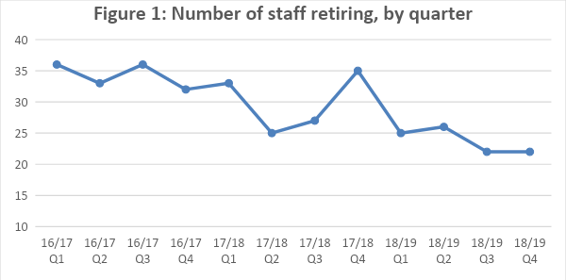

Annual turnover, using total leavers, has declined from 17 per cent in 2017/18 to 12 per cent in 2018/19.
Over 35 percent of delegates said that attending the course had made them think they would carry on working longer with the Trust, while less than 5 percent suggesting the course made them think they would go sooner, according to survey results in 2018. We can’t be certain that the course is the only reason the retention stats have improved but this particular figure does demonstrate that around a third of people are saying they think they will stay longer after attending.
Another method of assessing the programme is to see whether staff retiring as a percentage of the workforce aged 55 and over has declined. Indeed, this is the case. Retirements on this basis fell from 11 percent in 2017 to 9 percent in 2018.

Table 2 – Retirements as a percentage of the workforce aged 55 and over
Year | Retirements | 55 and over | Percent
2016/17 | 137 | 1204 | 11%
2017/18 | 120 | 1361 | 9%

This is a better measure than retirements as a percentage of the total workforce, as this may decline if there are many recruits who are too young to retire this will show a reduction in the retirement rate due to this factor alone, all other things being equal.

The pre-retirement programme
The purpose of the programme:
- Helping employees plan their future.
- Encouraging employees to consider extending their time with the NHS, but not necessarily working the same hours as they do currently.
- Educating employees on their pension options and how this might fit into their wider financial plans, potentially alongside a phased or staggered approach to retirement.
- After the workshop, delegates can construct a personal plan, having looked at all the options and implications for their future.
The programme is supported by a managers’ briefing webinar. Managers are asked to discuss the workshops with staff and positively support their attendance. In addition, discussions regarding future plans should be a standard agenda item for annual appraisals. Managers also need to understand fully all the flexible options available.
The programme is run by Lee Coles, Head of Workplace Education, Jelf EB

Steve Gregoriou, Workforce Planning Development Manager, NELFT
Steve.Gregoriou@nelft.nhs.uk, steven.gregoriou@nhs.net
George Blair, Managing Consultant, Shared Solutions Consulting george@sharedsolutions.net
Lee Coles, Head of Workplace Education, Jelf EB
Lee.Coles@jelf.com

