 | 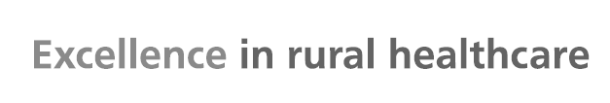 |  | 
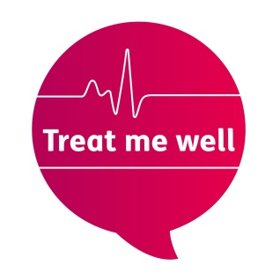 |  | Lincs Treat Me Well Action Group  (Hosted by ULHT)  Supporting toileting and bathroom needs  We hope to be able to develop ‘Changing Places’ within ULHT in the near future; in the meantime here are details you may find useful.
The nearest disabled bathroom is:

If you need physical assistance please speak to:

who will find someone to help you.

The nearest ward or department if you need to use a bed or trolley is:

Our PALs teams are always happy to help with any information you may need:

Pilgrim Hospital – main reception.
- 01205 446243
- 01205 446244
- Text: 07815 707746

Lincoln County – just past main reception; opposite ICU
- 01522 707071
- 01522 707072
- Text: 07815 707746

Grantham Hospital – in Corridor C just along from Ward 6.
- The office itself is not always open but there is always someone to speak to:
- 01476 464861
- 01476 464862
- Text: 07815 707746

You can also find further disability access information on the AccessAble website: https://www.accessable.co.uk/



