

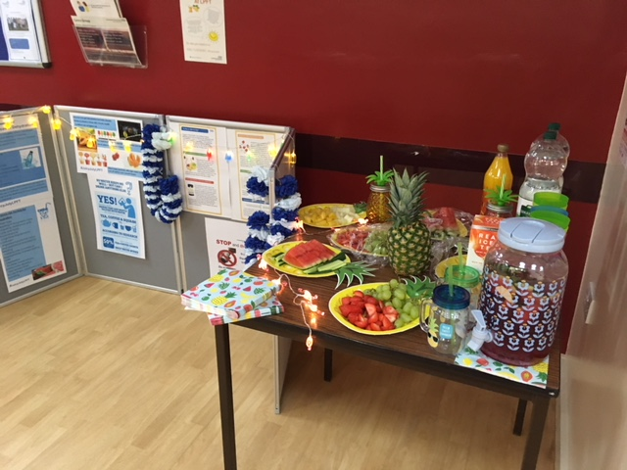**#LPFTJUICYJULY HYDRATION STATIONS**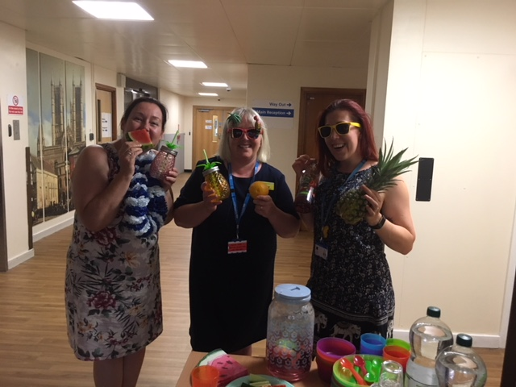

►Project Team: Lisa (Staff Wellbeing) Jane (IPC Nurse) Jacky (Inpatient Quality Champion) ►Series of ‘Hydration Stations’ across Trust ►Promoted widely internally & externally ►Tropical theme showed ways to hydrate e.g. lollies, smoothies, milkshakes, fruits & veg

**Do**

►Even mild dehydration adversely affects mental performance & increases feelings of tiredness ►Older people & those with chronic health conditions are at greater risk ►Dehydration increases risk of dizziness, falls, weakness, skin conditions, urinary tract infections

**Why is this important?**

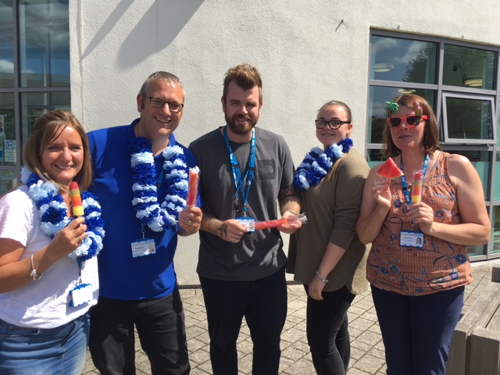 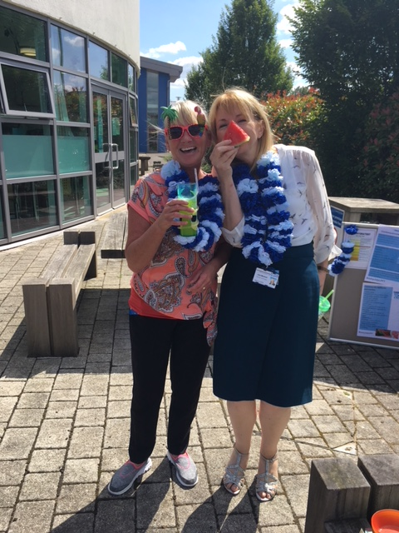 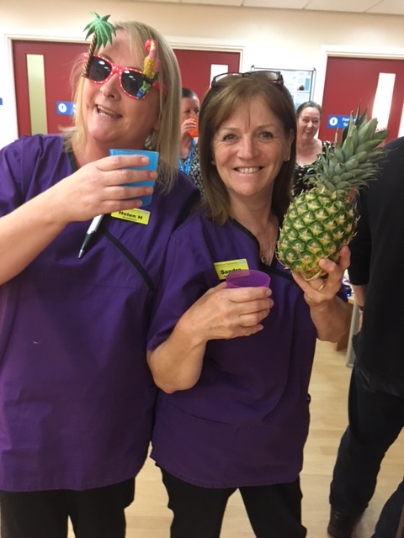 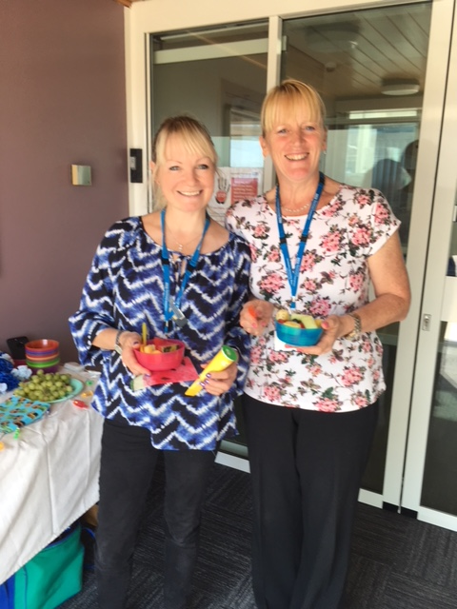

►Good attendance at Trust wide events ►#LPFTJuicyJuly used widely on social media & evident connection to importance of good hydration ► Evidence of ‘Hydration Stations’ adopted within staff teams Trust wide ►Positive verbal feedback & fun pics!

**Study**

►Additional internal events included e.g. training, forums & meetings ►Approach shared externally with FAB Ambassadors, ULHT, Nutrition & Hydration Week Team & Droplet UK ►Project Team to continue approach by promoting #LPFTWinterWarmers via social media & Coms. Team

**Act**



**QUALITY**

**IMPROVEMENT**



**Older Adult Inpatient Division**

**#Love Hydration Innovation project 2018/2019**

**Change idea: To raise awareness & improve hydration levels Trust wide with #LPFTJuicyJuly**

►Book events Trust wide to raise awareness ►Provide fun, interactive, accessible events to engage and inform staff, patients & carers ►Use social media to advertise, share & engage ►Monitor attendance & responses to social media to gauge success ►Support from Chief Exec to purchase supplies

**Plan**