

►Findings shared with Droplet re: alert system limitations in busy Ward environment ►IPC Nurse attending staff meetings to emphasis importance of hydration and accurate recording ►Further project commenced to address urine dip analysis in line with Public Health England ►Older Adult training scheduled re: nutrition, hydration & mealtime experience for people living with dementia ►#LoveHydration Project Team planning events throughout the summer

**All teach, all learn**

►Review of fluid charts – inconsistencies identified ►Review of urinary tract infections and prescriptions for antibiotics - further projects identified to address urine analysis issues ►Use of Droplet products monitored ►Staff and patient feedback collected

**Study**

►Project launched Feb 14 to promote #LoveHydration with gift/info bags for staff ►Droplet products with visual/vocal alert system introduced on Langworth Ward ►Droplet mugs/beakers and strong flavoured squash introduced at Manthorpe Centre ► Risk Assessment created for products

**Do**

►Droplet mugs/beakers continue to be used with positive feedback ►Droplet bases unsuitable for Ward environment; shared with Community Teams ►Wards supplied with variety of drinks to continue hydration promotion & meet patient preferences

**Act**

Gift & Information bags for staff

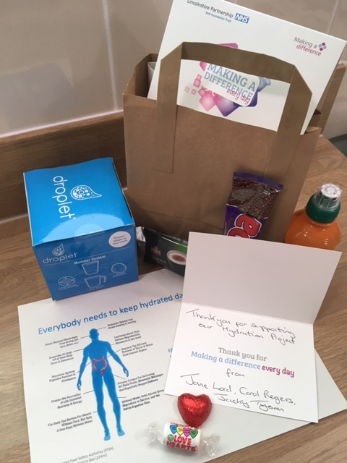



**QUALITY**

**IMPROVEMENT**



**Older Adult Inpatient Division**

**#Love Hydration Innovation project 2018/2019**

**Change idea: To improve patient hydration levels by introducing ‘Droplet’ Products**

►Evidence of increased incidence of urinary tract infections during summer months on Wards ►Research indicates hydration levels directly linked to issues such as falls and increased confusion in older adults ►’Droplet’ product, designed for older adults, has evidenced improved levels of hydration

**Why is this important?**

►Invite ‘Droplet’ to demo product ►Submit idea for LPFT Innovation Funding ►Identify 2 pilot sites, one to use ‘Droplet’, 1 to be control ►Set launch date ►Collect baseline data 4 weeks prior to start ►Engage Ward Staff, Patients/Carers

**Plan**