Shape the Future: Nurse Ana starts research journey with study aiming to help patients facing pain after surgery
Published: 08 November 2023

Print
Shape the Future: Nurse Ana starts research journey with study aiming to help patients facing pain after surgery | NIHR

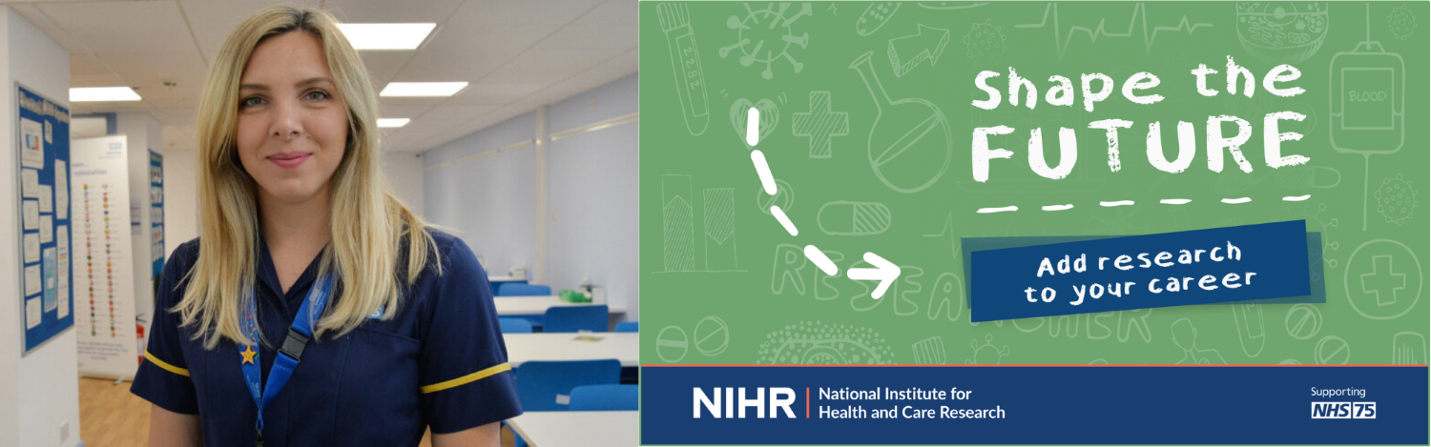
A nurse from Somerset NHS Foundation Trust has shared her experience of developing and running a research study to investigate an area of interest from her clinical practice.
Ana-Maria Toth had an idea for helping people with pain following surgery, and transformed it into a pilot research study now being delivered at the Trust.
The study, Hypnopal, is aiming to recruit at least 40 patients to receive hypnosis while they’re recovering from a colectomy, to check whether it helps with their pain and overall recovery.
Ana previously worked on Musgrove Park Hospital’s gastroenterology ward, before moving to a surgical ward, where she began to look at different ways of managing people’s pain in the days after surgery.
“The idea of my study began while I was working as a junior sister on the colorectal surgery ward – Montacute ward – as I identified a few things that I felt might help with people’s pain after surgery, particularly after a colorectal procedure,” she said.
“The current management for peri-operative pain is multi-modal analgesia (a combination of medicines), including opioids, which are widely used, but not well tolerated due to their numerous adverse effects.
“Pain management after an operation can be different for each individual patient, and we’re always looking for ways to control pain, which makes it easier for patients to get up and about and get back to normal food and drink intake – we’re keen to find out the extent to which hypnosis could help with this.
“It prompted me to think about whether there was something else we could offer our patients that doesn’t involve medication, so I started researching hypnosis and I saw that it had been used elsewhere, in breast surgery and for patients recovering from burns.
“I then undertook an undergraduate degree in medical hypnosis at the University of Birmingham in my spare time, and I was joined by a range of other healthcare professionals across the country, including GPs, dentists, anaesthetists and nurses.
“I achieved my diploma and started to think about how I could bring my practice into the NHS through a potential research study. I applied for a grant through one of our trust charities, Love Musgrove, which agreed to fund my part in the study.
“My research project looks at how we can use hypnosis to help with pain after a patient has had a colectomy operation.
“The main focus is on pain, but it also looks at patients’ recovery, their length of stay in hospital, how fast they mobilise, and get back to eating and drinking.
“Hypnopal began in July 2023 and will look at 40 patients over the course of a year – I’ve already recruited a handful of patients so far, which is great news.
“I take part in patients’ multidisciplinary team meetings with our consultant surgeons and other professionals, such as radiologists and oncologists, every Monday when they discuss upcoming cases of surgery.
“Then I screen patients from the surgery lists, and I go into the clinics with the surgeons, who tell me about the care and treatment plan for each patient, including other treatments they might need. At the same time, they mention the Hypnopal study to each patient and ask whether they’d like to take part.
“I send them an information pack, giving them time to read up about it, and then three days later I’ll call them to see if they’d be interested in joining the study.
“If they’re happy to take part then we’ll have an initial consultation and a computer randomisation process will choose whether the patient is assigned into a ‘control group’ or an ‘intervention group’.
“The intervention group offers hypnosis on top of the standard care, which is all the regular care they’d normally get. Patients in the ‘control group’ just receive the regular care without hypnosis.
“For patients allocated to the intervention group, the first hypnosis session will be offered at our first consultation. I will see them again 24 hours after their operation, when they’ll have a second hypnosis session, and a third hypnosis session will be offered three days after surgery. Then I follow up with the patient on the day they leave hospital, as well as 10 days later.
“I will collect data about their pain level and general wellbeing, how they mobilised, and how they ate and drank during that time – all part of their recovery.
“Once we’ve recruited enough patients, a statistician will compare the data collected from the two groups and results will be used to inform a future larger study.”
Ana said she understands that some people may be nervous about the concept of hypnosis after watching certain TV shows, but reassures that there are lots of safeguards in place and the study has been through the standard governance and ethics protocols.
“We’re using hypnosis in a really positive way to see if it benefits a patient’s care,” she continued. “If it proves to be beneficial to patients, then there’s scope for an even larger trial to be run across the country in the future.
“My message to patients thinking about joining the hypnosis trial is that they really have nothing to lose as they’d still get the same level of care as before, but with the potential addition of hypnosis.
“At the very least it will relax patients and we hope that the trial will show many other benefits too. I hope that curiosity wins out over fear!
“We’re the only trust in the country trialling hypnosis following colorectal surgery so it would be a really big discovery if the results prove that it works!”
Ana’s study has received widespread media coverage, read an article and watch a clip from ITV Westcountry here: https://www.itv.com/news/westcountry/2023-10-03/patients-being-hypnotised-to-help-with-pain-relief-after-surgery
Find out more about how the NIHR can support you on your research journey: https://www.nihr.ac.uk/health-and-care-professionals/training/

