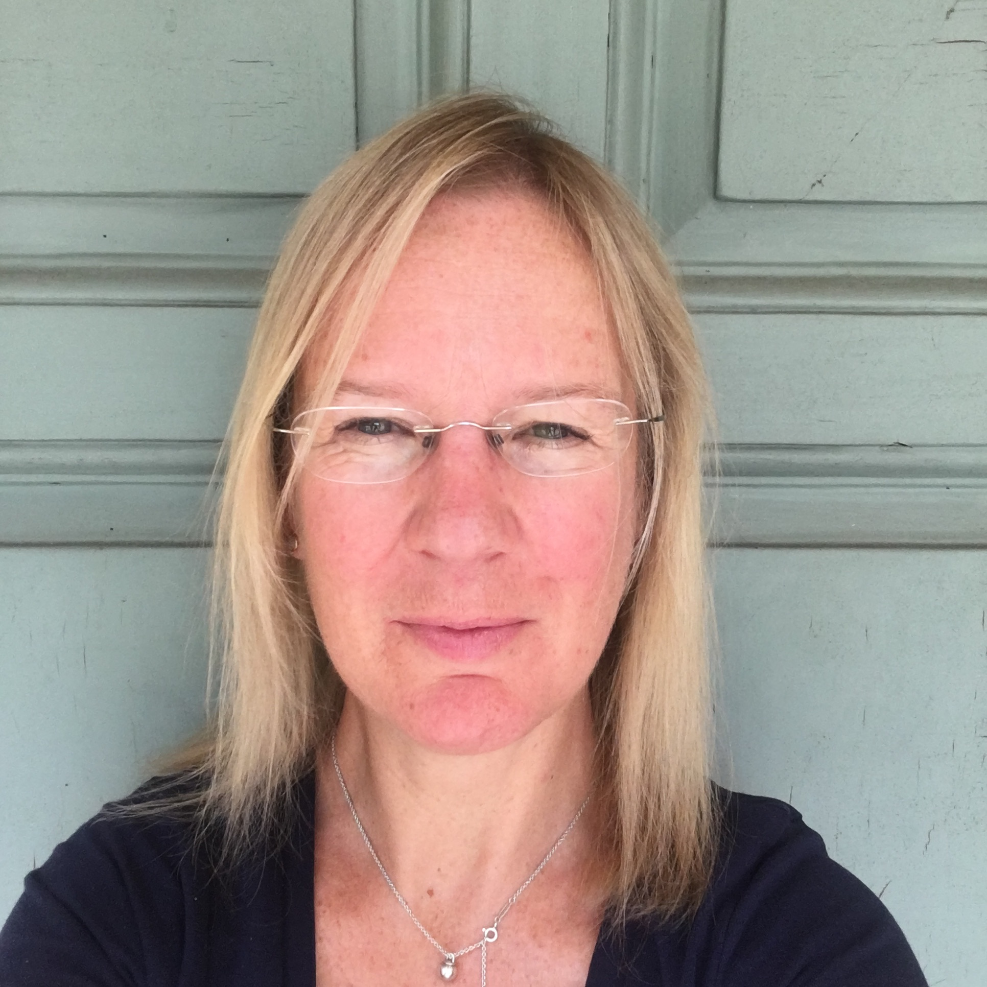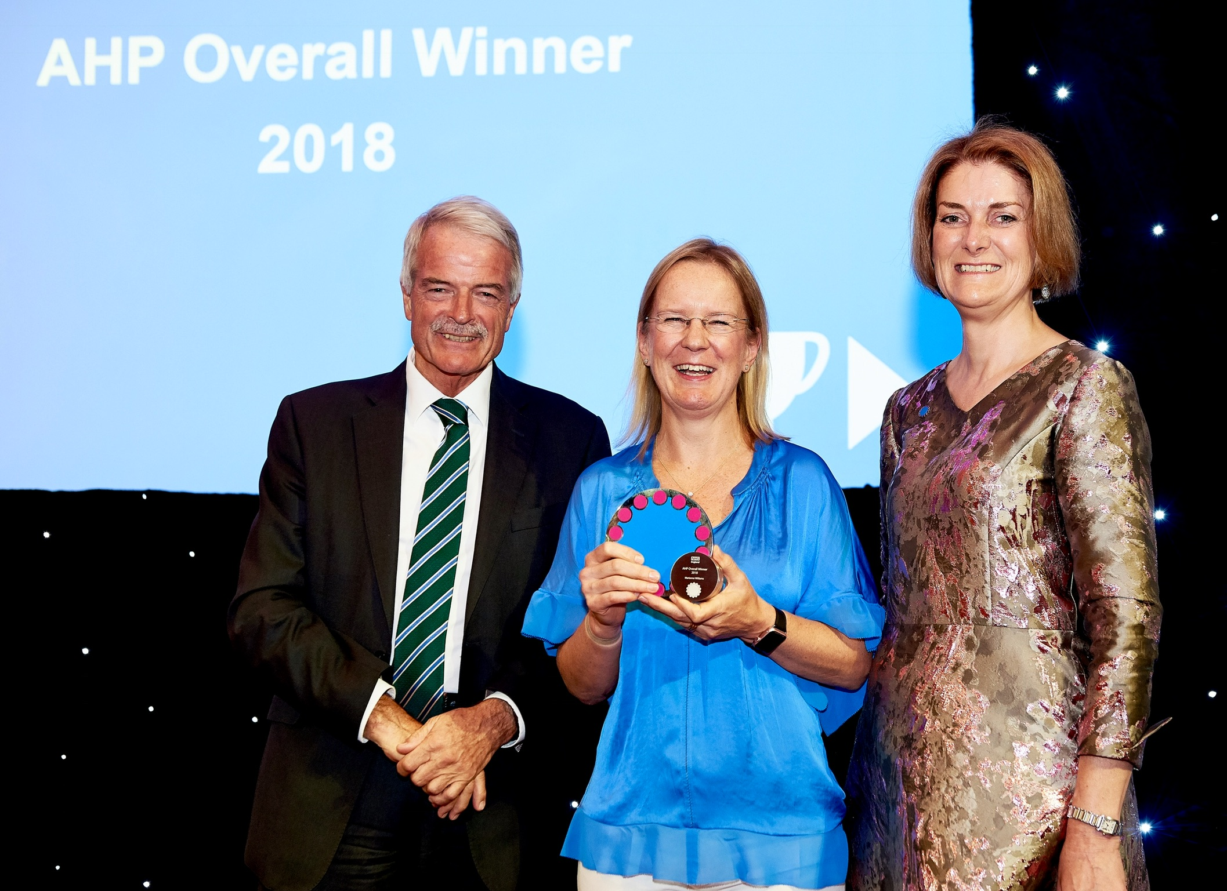
https://digital.nhs.uk/blog/transformation-blog/2019/

Digital Allied Health Practitioner of the Year 2018

Over the last 4 years NHS England, NHS Digital, Health Education England and the National Institute of Clinical Excellence have been sponsoring the Allied Health Professional (AHP) AHP’s into Action.

Marianne was awarded the NHS Digital Practice Award and overall AHP Award for 2018.

Marianne, can you introduce yourself and why you began using webinars with your patients?

I’m a Specialist Gastroenterology Community Dietitian, working with the community dietetic services in Somerset Partnership NHS Foundation Trust. We undertook the NHS England 100 Day Project in 2017.

Can you explain what project was about?

The aim of the project was to develop new solutions for old problems and overcome barriers that were historically preventing practical and economical patient care. As a team we decided that we could focus on improving patient education. Webinars directed at patients were seen as a new and effective way to deliver education directly to patients and reduce need to duplicate information.

Which cohort of patients did you choose, and why?

We choose patients with Irritable Bowel Syndrome as the pilot cohort as IBS is a chronic and debilitating condition which affects 10-20% of the UK population. This condition has considerable financial implications with the attributable cost in the UK estimated at almost £12 million per annum in 2012-2013 and uses up significant amounts of clinical time in both primary and secondary care.

These webinars have proved exceptionally popular and effective in Somerset with 95% of patients stating that they would recommend the webinar to friends and patients showing that they had improved their knowledge post webinar attendance.

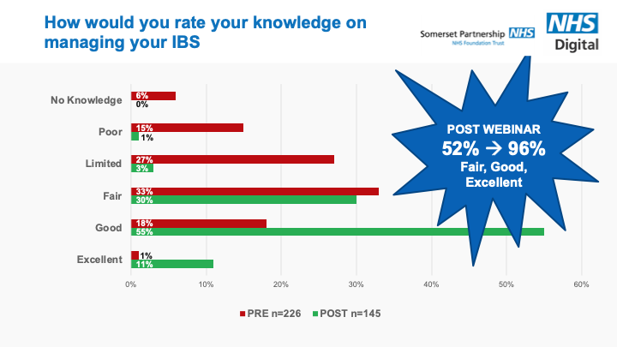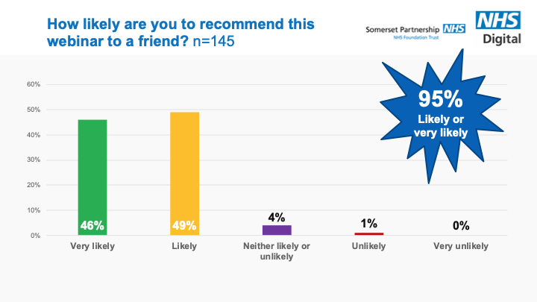

Why did this particular project win the national awards from both NHS England and NHS Digital in 2018?

Suzanne Rastrick, Chief Allied Health Professions Officer, along with judges from NHS England and NHS Digital could see the potential for scalability and impact of this project nationally.

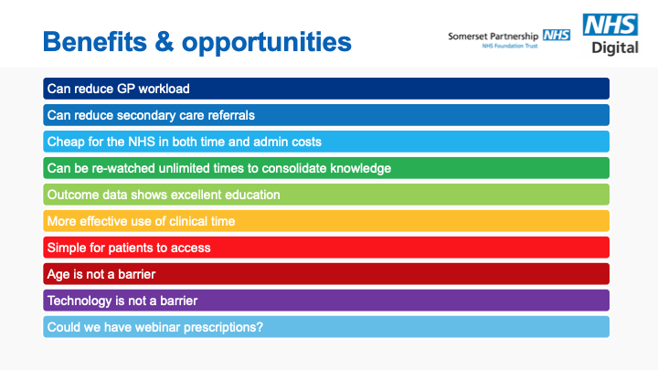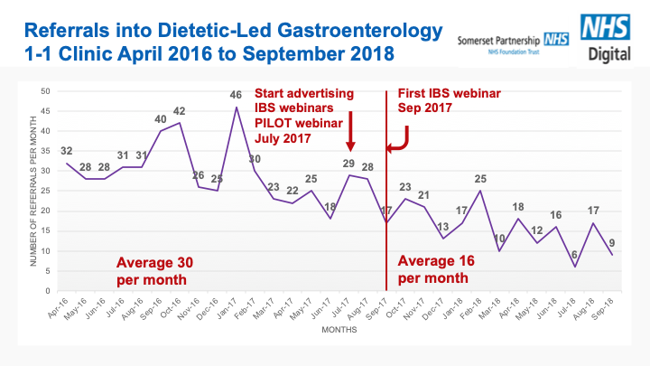

It was clear that there were many practical and financial benefits of running webinars for patients and indeed, the use of webinars substantially reduced referral rates into the 1-1 dietetic specialist gastro service. Hence, the webinars have released valuable clinical time and this service is now able to take on new conditions such as IBD in remission and coeliac disease – this would have been impossible prior to the webinars.

What do you think are the next steps to promoting the use of webinars nationally?

Since, winning the award, I have been working with Jeremy Wilkinson from NHS Digital realising the vision to create a repository of webinars for patients by NHS clinicians nationally and free for all to use.

The webinars we have created in Somerset have all now been given full endorsement by the British Dietetic Association, and through Jeremy Wilkinson I have been able to give talks on the success of the webinars to the NHS Digital Clinical Conference, NHS Digital Health webinar series, Health & Care Conference, Kings Fund Conference and I am very honoured to be speaking at this year's NHS Health Summer School in Leeds in July.

There has been considerable interest from NHS Trusts nationally in producing webinars for their patients in many areas of medical discipline such as radiology, maternity, MSK, bariatrics, diabetes, renal, paediatrics and more. As a result, we have formed a ‘Working Group’ of national clinicians who have expressed a keen interest in being involved in this project. This has led to the creation of a Framework for Adoption which can be used to guide any departments in the UK wishing to set up patient webinars.

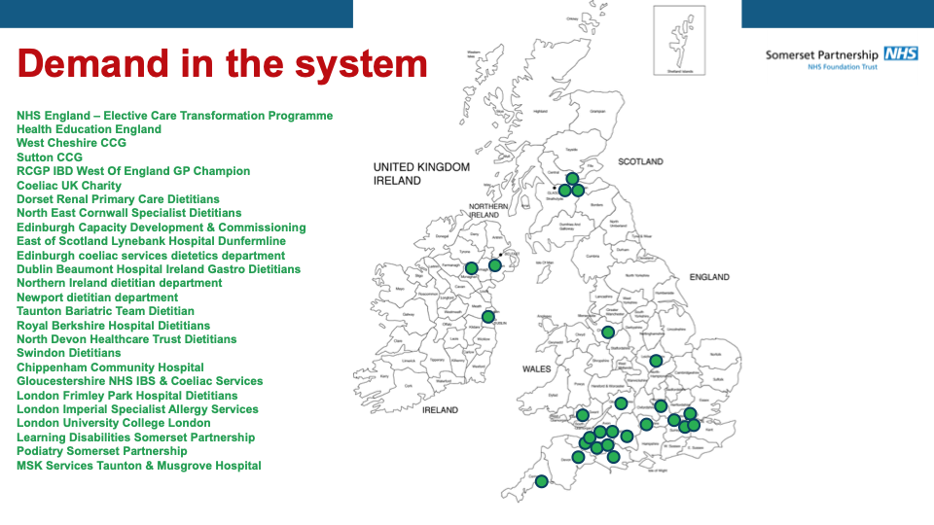

We have been working with the NHS UK team over the last few months to create a link on their website directly to the IBS First Line Advice webinar and this went ‘live’ last week: https://www.nhs.uk/conditions/irritable-bowel-syndrome-ibs/further-help-and-support/?a=1. This is a pilot by NHS UK to see if this form of patient education works effectively at a national level.

We are now working with the British Dietetic Association and our GP colleagues in Stockport and Greater Manchester CCG to look at encouraging GP ‘prescription’ of these webinars via NHS UK to collect further health economic outcome data.

