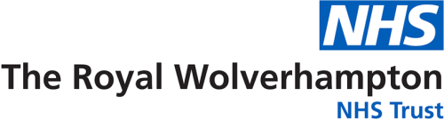

**Evaluation and Remodel of Undergraduate practical skills during COVID-19**

**By Melissa Jayne Whiles, Lead for Undergraduate Clinical Skills and Simulation**

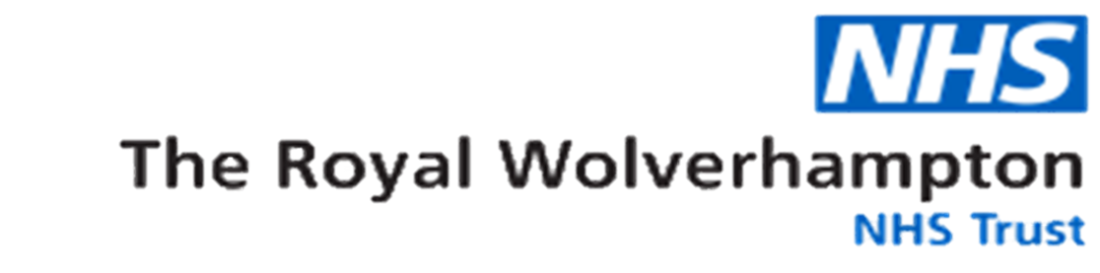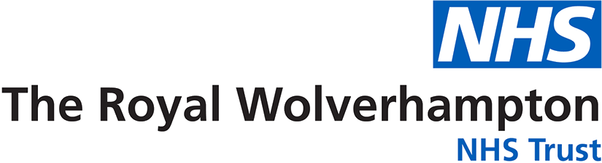

**July 4th 2020**

Prime minister relaxes guidance. 1m social distancing to remain

**May 10th 2020**

[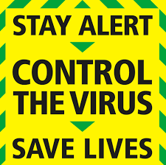](https://www.google.co.uk/url?sa=i&url=https://www.huntspost.co.uk/news/government-stay-alert-plan-released-after-boris-johnson-bbc-address-1-6647748&psig=AOvVaw0JklQJFXlGswFCQIWhWy8L&ust=1605872593920000&source=images&cd=vfe&ved=0CAIQjRxqFwoTCLi7o97Dju0CFQAAAAAdAAAAABAE)

**March 23rd 2020**[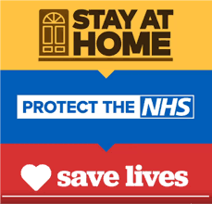](https://www.google.co.uk/url?sa=i&url=https://www.westofengland-ca.gov.uk/west-of-england-leaders-urge-people-to-stay-at-home-protect-the-nhs-and-save-lives/&psig=AOvVaw2MGPAqAFT-ncmyipg3Ks2y&ust=1605870149874000&source=images&cd=vfe&ved=0CAIQjRxqFwoTCLj739C6ju0CFQAAAAAdAAAAABAE)

**March 16th 2020**

Prime minster encourages 2m social distancing

**March 5th 2020**

First reported UK COVID-19 related death

**How did we do it?**

In June a strategy meeting was held between the Clinical Skills Department and Clinical teaching fellows where a decision was made to utilise digital platforms such as iSpring to reduce face to face training.

Studies were then researched to look at the comparison of different teaching / learning modalities and if undergraduate medical students consider there being a place for e-learning in their education, of which the results were predominantly positive.

The UoB mandated curriculum of practical skills were then divided between the CTFs to develop e-learning packages containing video demonstrations to support different learning modalities of visual and auditory. During production of these packages there were regular progress review meetings before the completion date at the end of July.

Medical associates then piloted the e-learning packages, whereby the feedback was overwhelmingly positive, before being presented to the Head of Teaching Academy, Dr James Bateman.

On 1st September all semester 1 e-learning packages were uploaded to Moodle for access by UoB medical students, with feedback obtained via QR coded questionnaires, which again was all predominantly positive.



**Background**

The General Medical Council (GMC) expects all newly qualified doctors are able to safely and effectively perform a mandated list of practical skills and procedures. The medical students from the University of Birmingham (UoB) receive a curriculum which supplements those expected requirements.

During COVID-19 all non-essential face to face training was either put on hold or had very strict restrictions around social distancing, in line with government guidance and Royal Wolverhampton Trust (RWT) escalation plan.

**100% strongly agree / agree their knowledge was improved; they would feel confident in practice and would recommend to their peers**

**£1112.90 per annum saved for the Education and Training directorate!**

**36 hours saved per annum!**

**What was the result?**

Less people were bought together in the skills lab for any length of time, therefore creating a safer environment. It gave the students more autonomy and more time to be clinical with patients in a time when the hospital was under great strain due to staff shortages. In total it saves the Clinical Skills and Resuscitation departments 36hours in training per annum, which in turn saves the Education and Training directorate £1112.90 per annum also.

**36 hours saved in training per annum!**

**£1112.90 per annum saved for the Education and Training directorate!**

**Conclusion**

The inclusive feedback for this project was undeniably positive, which has now given the credential to go ahead with developing the same e-learning packages for semester 2 skills. To improve on what was done for semester 1, a microphone for better auditory quality has been requested from the Undergraduate Department. These packages will enable the students to continue their learning in the event of another pandemic and will also undoubtedly be hugely beneficial to the medical students of Aston Medical School who will be joining us in September 2021. Overall a huge success!

**Conclusion**

The inclusive feedback for this project was undeniably positive, which has now given the credential to go ahead with developing the same e-learning packages for semester 2 skills. To improve on what was done for semester 1, a microphone for better auditory quality has been requested from the Undergraduate Department. These packages will enable the students to continue their learning in the event of another pandemic and will also undoubtedly be hugely beneficial to the medical students of Aston Medical School who will be joining us in September 2021. Overall a huge success!

References

General Medical Council. 2019. Practical Skills and Procedures. London: General Medical Council.

British Foreign Policy Group. 2020. COVID-19 Timeline - British Foreign Policy Group. [ONLINE] Available at: <https://bfpg.co.uk/2020/04/covid-19-timeline/>. [Accessed 19 November 2020].

Gormley GJ, Collins K, Boohan M, Bickle IC, Stevenson M. Is there a place for e-learning in clinical skills? A survey of undergraduate medical students' experiences and attitudes. Med Teach. 2009 Jan;31(1):e6-12. doi: 10.1080/01421590802334317. PMID: 19253150.

Mir, M. A., Marshall, R. J., Evans, R. W., Hall, R., & Duthie, H. L. (1984). Comparison between videotape and personal teaching as methods of communicating clinical skills to medical students. *British medical journal (Clinical research ed.)*, *289*(6436), 31–34. https://doi.org/10.1136/bmj.289.6436.31