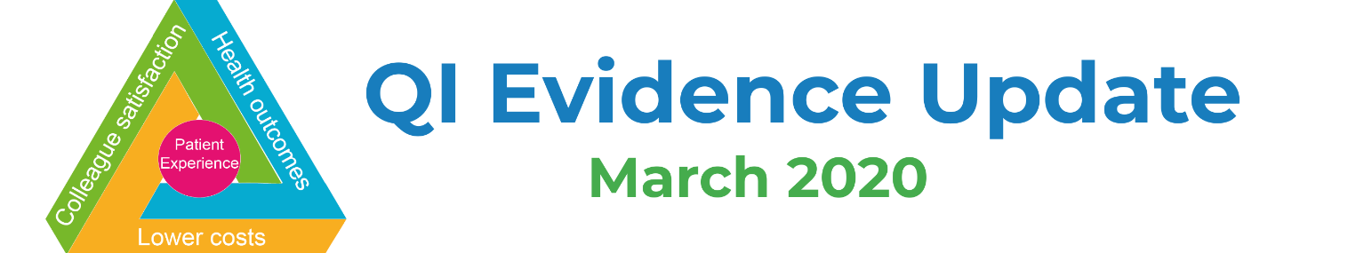
Improvement
- Guide to hibernating Quality Improvement programmes (Healthcare Improvement Scotland, March 2020)
- Using logic models to evaluate innovations in health care (Nuffield Trust, Mar 2020)

COVID-19
- Coronavirus guidance for clinicians and NHS managers (NHSE/I)
- Finding the evidence: Coronavirus (Public Health England, March 2020)
- COVID-19 learning materials for professionals (NHS Education for Scotland, March 2020)
- WHO Database of publications on COVID19 (WHO, March 2020)
- NICE rapid guidelines and evidence reviews (NICE, March 2020)
- Coronavirus (COVID-19) - Cochrane resources and news (Cochrane, March 2020)
- Coronavirus (COVID-19): articles and resources (MAG Online Library, March 2020)
- Oxford COVID-19 Evidence Service (Oxford Centre for Evidence Based Medicine, March 2020)
- Coronavirus (COVID-19): Evidence Collection (Evidence Aid, March 2020)
- COVID-19 reports (Imperial College London, March 2020)
- The Royal College of Emergency Medicine Covid-19 Resources (RCEM, March 2020)
- BMJ Best Practice (BMJ, March 2020)
- JAMA Network COVID-19 Resource Center (JAMA, March 2020)
- UpToDate (UpToDate, March 2020)
- COVID literature scan of 1300+ PubMed articles for clinicians and medical educators (Sachin Shah, Assistant Professor, University of California, San Francisco, March 2020)
- LitCovid - curated literature hub of Covid-19 articles (March 2020)

Leadership and Communications
- Communicating during an outbreak or public health investigation (Center for Disease Control and Prevention, 2019)
- Leadership in a crisis: Responding to the coronavirus outbreak and future challenges (McKinsey, March 2020)
- Resources for resilient leadership: Actions for senior executives responding to COVID-19 (Deloitte, March 2020)
- Communicating with Staff (NHS Employers, March 2020)
- How to encourage your leaders to be virtually visible (allthingsIC, March 2020)

Wellbeing
- The Chaos of Coronavirus: How to Protect Your Mental Health (Thrive Global, March 2020)
- Health, Safety and Wellbeing – Resources from NHS Employers (March 2020)
- Free Apps to wellbeing apps for all NHS staff (NHS Employers, March 2020)
- Mental Health Considerations during COVID-19 Outbreak (WHO, March 2020)
- Mental health strategies to combat the psychological impact of COVID-19: beyond paranoia and fear (Annals, Academy of Medicine, Singapore, March 2020)
- Look after your mental health and wellbeing if you are staying home (Mental Health Foundation, March 2020)
- National discounts for NHS workers (NHS Employers, March 2020)

Adjusting to remote working
- A Comprehensive List of Tips, Tools, and Examples for Event Organizers During the Coronavirus Outbreak (CMX blog, March 2020)
- How to Work From Home: 20 Tips From People Who Do It Successfully (HubSpot blog, March 2020)
- Collection of working from home resources (Health Education England, March 2020)
- Virtual Working Resources (NHS Horizons, March 2020)
- The Remote Work Survival Kit – live, cocreated toolkit that you can contribute to
- How to create belonging for remoteworkers (MIT Sloan, Feb 2019)
- Five ways to improve communication in virtual teams (MIT Sloan, June 2018)
- How to Run a Great Virtual Meeting (HBR, March 2015)
- Managing Through Crisis: How To Work Remotely - video (Harvard Business School, March 2020)

Patient Experience & Engagement
- Decision aids including leaflets and computer programs help patients make treatment choices (NIHR Signal, Mar 2020)
- Making the most of patient experience data (Picker, March 2020)
- Structured nurse ward rounds support accountability and risk management but not nurse-patient communication (NIHR Signal, Feb 2020)
- A rough guide to public involvement (NIHR Imperial BRC Patient Experience Research Centre, January 2020)

Technology
- Avaya supports containment of COVID-19 virus by donating a Remote Visitation System (Health Tech Digital, Mar 2020)
- NHS trust saves its nurses nearly 20,000 hours a year through ePMA (Health Tech Digital, Feb 2020)

Events & Training
- Coronavirus (COVID-19) programme (e-learning, HEE, March 2020)
- Game: “Coronavirus: know the facts” (Focus Games)
- IHI Open School – free for everyone for limited time
- Elective Care Community of Practice online platform (free – join now!)
- Fab Change Day 2020, 21 October 2020 (The Academy of Fabulous Stuff)

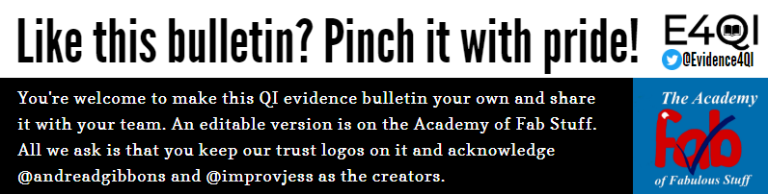

Thank you to Kevin Burgoyne, Specialist Healthcare Librarian at Brighton and Sussex NHS Library and Knowledge Service (@BrightonSx_LKS) for sending us an item for inclusion in this bulletin.

