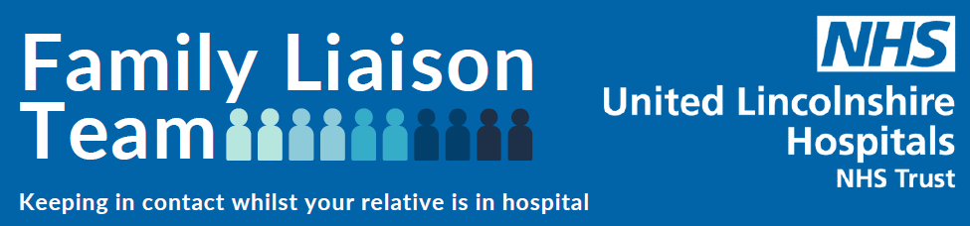

Introducing our new Family Liaison Team!

Having visitors when you are in hospital is known to be a very important part of the recovery process; evidence shows people recuperate faster and visitors can help reduce stress and anxiety.

However we are in unprecedented times during the COVID-19 pandemic and have sadly had to suspend all visiting to our wards at Boston, Lincoln and Grantham Hospitals.

Recognising the value of visitors and the added anxiety of being isolated we have developed a Family Liaison Team to act as your link and connection to patients whilst you are unable to.

The team is led by our Chaplaincy Service and is manned by amazing Volunteers and we are truly grateful to everyone for helping us make this come alive.

The team have bases on each of the 3 main hospital sites and are able to support with:

- Taking and passing on non-urgent messages for patients and then contacting you back to confirm and if there is a response.

- Receiving and delivering personal items patients may need (there are some important restrictions here so please read the separate guidance to be found below).

- Supporting patients to undertake a Skype or FaceTime video call if they do not have the technology to do so.

- We are also launching a ‘Letter to a Loved One’ scheme! Just ask the team about this when you call.

To contact the team please call one of the numbers detailed below.

We aim for the service to be open Monday to Friday 10:00 – 16:00 though this is reliant on having enough volunteers to man the phones. Please bear with us and leave a message on the answerphone and we will call you back as soon as possible.

Patient’s property and bringing personal items into hospital

We fully appreciate how important personal items are for our patients, and particularly in the current situation when they are not able to have visitors. However we do need to ensure we manage the situation carefully to minimise the risk of cross infection. As such we are implementing the following controls and would like to thank all relatives and carers for their support in helping us reduce risk to patients and staff.

We have developed a Family Liaison Team (FLT) run by our Chaplaincy service and Volunteers; this team will be the hub for receiving and passing on items to patients; we ask that people are patient as it is reliant on volunteers so that we do not put undue demands on ward staff.

The following items are not permitted to be brought in:
- Clothing – other than those brought in for when someone is being discharged. This is because we have no facilities to launder personal property and cannot have it building up at the bedside nor do we have the capacity to decontaminate and return it to families on a regular basis.
- Food and drink. We will provide for all nutrition and hydration needs and there are risks associated with having sundries that may become out of date or contaminated.
- Flowers or plants.
- Anything made of fabric or materials that cannot be wiped clean.

We ask that:
- You keep any items brought in to an absolute minimum as everything needs to be cleaned regularly and will add to the cleaning workload.
- Any items brought in are small and can be kept safely in or on a bedside locker.
- Valuable items should not be brought in; we cannot take responsibility for items retained by patients at the bedside and have limited ability to secure valuables.
- Any messages or drawings on paper are placed in a plastic pocket which can be wiped over.
- Items are placed in a plastic bag clearly labelled with the patients name, date of birth and the ward in which they are being cared.

Suggested permitted items only if absolutely essential include:
- Phone or tablets and chargers
- Books
- Photographs in a frame

If you have items within these limitations that you wish to bring in please first call the Family Liaison Team on the numbers below and discuss the time you would like to attend to drop them off. Our team will do everything possible to accommodate your availability but please bear with us as it is run by volunteers. On meeting you we will have a clear plastic bag that we ask you to put your bag into and we will then take it down to the ward for you.

Thank you for your support and understanding.

