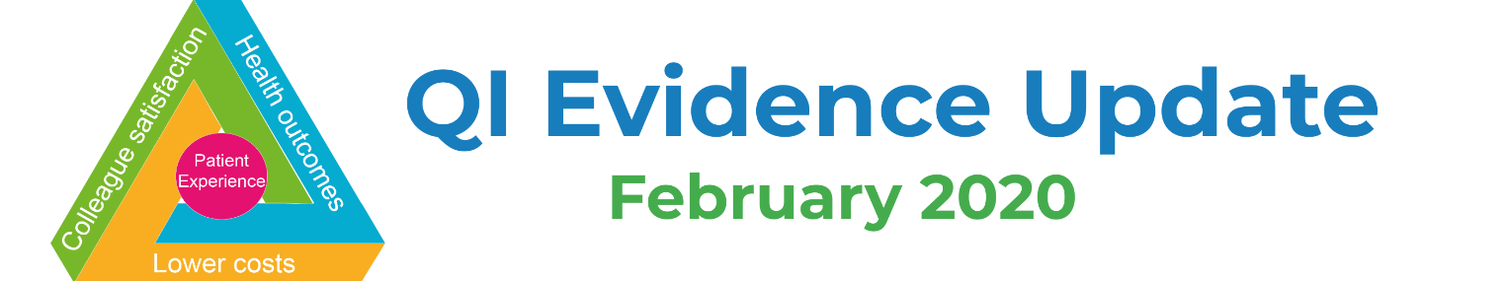
Improvement
- Update from RCP Quality Improvement: Improving improvement through practice, learning and research (Future Healthcare Journal, February 2020)
- ICU admission decision support tool showed promise but was rarely used (NIHR Signal, Feb 2020)
- NHS health check attendance improves with changes to the invitation letter (NIHR Signal, Feb 2020)
- Leading with empathy: case study from East Lancashire Hospitals NHS Trust (NHSE/I, Feb 2020)
- Context, complexity and process in the implementation of evidence-based innovation: a realist informed review (BMC Health Services Research, Feb 2020)
- A systematic review exploring the content and outcomes of interventions to improve psychological safety, speaking up and voice behaviour (BMC Health Services Research, Feb 2020)
- Unpacking organizational readiness for change: an updated systematic review and content analysis of assessments (BMC Health Services Research, Feb 2020)
- Defining sustainability in practice: views from implementing real-world innovations in health care (BMC Health Services Research, Feb 2020)
- Innovating for improved healthcare (RAND Corporation, Jan 2020)

Patient Experience & Engagement
- What matters to people using A&E (Healthwatch, Feb 2020)
- Picture books on prescription (The Guardian, Feb 2020)
- Moving beyond project-specific patient and public involvement in research (Journal of the Royal Society of Medicine, Jan 2020)
- Anonymity, veracity and power in online patient feedback: A quantitative and qualitative analysis of staff responses to patient comments on the ‘Care Opinion’ platform in Scotland (Digital Health, Jan 2020)
- How to … a series of guides, toolkits and resources for patient and public involvement (Wessex Voices, undated)

Efficiency & Planning
- Finding the evidence: Coronavirus (PHE Knowledge and Library Services Team, Feb 2020)
- Infographics: Fair shares – A guide to NHS Allocations (NHSE/I, Feb 2020)
- Thinking differently about commissioning: learning from new approaches to local planning (Kings Fund, Feb 2020)
- What are health inequalities? (Kings Fund, Feb 2020)
- Government announces digital hospital-to-pharmacy referral service to cut hospital readmissions (The Pharmaceutical Journal, Feb 2020)
- Rebuilding our NHS: why it’s time to invest (NHS Providers, Feb 2020)
- ‘Handing over to the patient’: A FRAM analysis of transitional care (Applied Ergonomics via Patient Experience Library, Jan 2020)
- NHS financial management and sustainability (National Audit Office, Jan 2020)

Technology
- New tech allowing district nurses to digitally monitor wounds (Nursing Times, Feb 2020)
- Skin cancer apps ‘cannot be relied upon for accurate results’, study finds (Digital Health, Feb 2020)
- NHS launches temperature-triggered bus shelter ad campaign (Marketing Communication News, Feb 2020)
- North Lincolnshire lung patients first in UK to be offered ‘virtual rehab’ (Digital Health, Feb 2020)
- The Benefits of using Video in healthcare (Health Tech Digital, Feb 2020)
- Text messaging support helps smokers quit, but apps not yet shown to work (NIHR Signal, Feb 2020)
- Impact of online or app-based assessment for urgent health problems largely unclear (NIHR Signal, Feb 2020)
- How-to guide: non face-to-face clinics (UCL Partners, Jan 2020)

Events & Training
- Webinar: Scaling innovation: learning from asset-based approaches in social care (Kings Fund, 2 Mar 2020)
- Webinar: Increasing staff morale and implementing Joy in Work, 13 Mar 2020 (Q Community)
- Event: Central London Community Healthcare Improvement Celebration Event, 19 Mar 2020, 9.00-17.00 (London, free)
- Webinar: Sketchnoting 101, 1 April 2020 (Q Community)
- Q members are entitled to a 15% discount to the International Forum on Quality and Safety in Healthcare in Copenhagen on 28-30 April 2020
- NHS ConfedExpo, 10-11 Jun 2020 (Manchester, free for NHS)
- Elective Care Community of Practice online platform (free – join now!)

Awards & Funding Opportunities
- Catalyst Projects, application deadline 11 March 2020 (The Health Foundation)
- Healthcare Education and Training (HEAT) Awards, nomination deadline 27 March 2020 (Health Education England)
- Common Ambition programme, deadline for expressions of interest late March 2020 (The Health Foundation)

