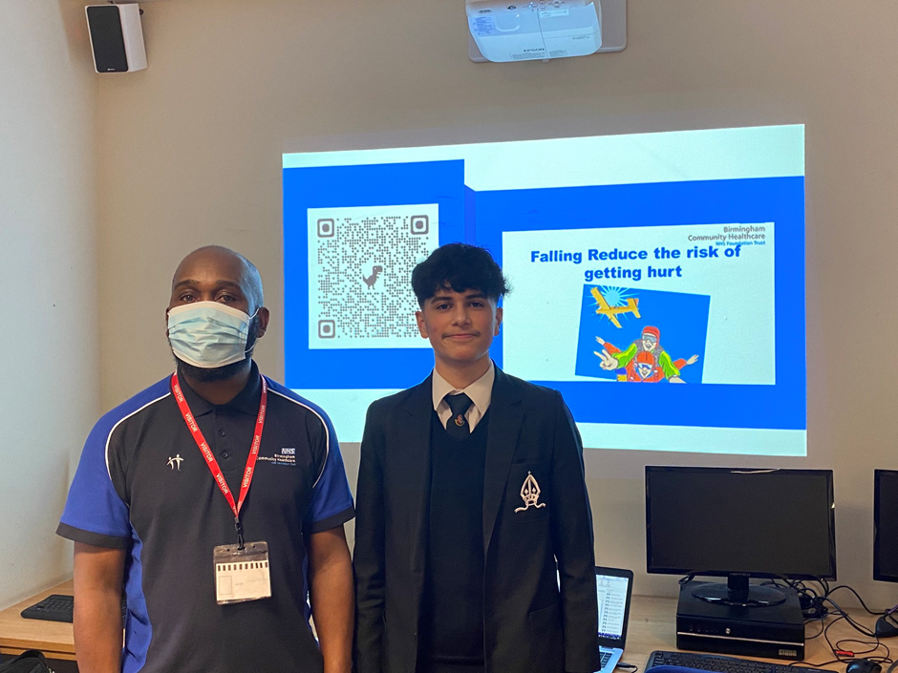

Falls Prevention @WalkingstickMOT

Student group Medical Minds team received training in how to reduce the risk of falls.

The next steps is for the Medical Minds team to visit local primary schools to train pupils in how they can support and educate the elderly people they know in how to avoid falling.

Bishop Veseys Grammar school Medical Minds lead, Shahram, and Head Teacher Dominic Bishop welcomed Paul Mills from the Falls Prevention Project.

Fall Facts
4 million Hospital bed days each year due to falls (source Royal College of Physicians)
60% of people who fall on the stairs die
1 in 10 who fall have increased isolation and reduced independence
10% probability of dying within a year
50 chance of impaired mobility after a fall
70,000 hip fractures annually
2 Billion Annual cost to NHS
13 People die every day as a result of a fall
The project is funded by Birmingham Community Health Care NHS Charity thanks to an @NHSCharities grant

Follow us on twitter @WalkingstickMOT
