Share your Fab Stuff!

2020 has been tough for health and social care. We want to make sure your fantastic work from the last year is celebrated, and that the learning isn’t forgotten.

We’ve drafted this template to help you structure your story. It’s designed to help others put your learning into practice. Try and complete every field if you can, but don’t worry if you can’t. When you have completed the template, please upload it, together with any attachments, to https://fabnhsstuff.net/login?ral=https://fabnhsstuff.net/upload-your-fab-stuff

Title of innovation / initiative
- Summarise your innovation / initiative – try to make it engaging!

Increased use of virtual technology and remote support for ICS pts in Care homes

Problem
- Please clearly and concisely describe the problem that you were trying to solve.

Intermediate Care helps facilitate discharges from hospital – majority of people return straight to their own home but a number of clients are placed in to a care home.
The majority of these clients receive rehabilitation vis the ICS therapists and along with keyworker plan for return to own home when able
Early in the COVID pandemic the care homes stopped all access to non-urgent visits( urgent considered acute medical decline/ safeguarding)
As a result no clients had access to the face to face therapy they would have received pre COVID
ICS recognised the need to support the care homes and help the staff support and manage those clients being discharged to their facilities. At the same time felt it important to think of ways to maintain/ improve clients function and avoid long term deterioration

Aim
- What were you trying to achieve? Try and make it specific - how much and by when?

for 100% of the ICS pts in care homes to be offered virtual support from April 20 until homes reopen to staff

Plan
- What did you do and how did you do it?
- What were the key steps / actions you took and changes you made?
- Did you use any improvement methodology or tools?

Agreed procedure is that coordinators inform clients/ family that there may be limited rehab at present if the homes are limiting their access
Once allocated to the team- ICS therapists phone the nursing home, explain that client has been referred for rehab, ascertain if they are having any difficulties with client’s transfers/ mobility etc. explain that rehab has been identified and enquire if home is agreeable to a face to face assessment. This is consistently happening with all referrals when clients are for rehab in nursing/ res homes
If declined the therapists offers virtual session, telephone advice, forwarding on written exercise programmes and advises home makes contact if clients ability changes. Client remains open to ICS and plan (via keyworker) as able/ appropriate for return home within 2 weeks to allow rehab to commence in own home. Therapists are finding that most patients (over 70%) are remaining in placement beyond 2 weeks- this is higher than we would normally expect. Feedback in relation to keyworkers is that they are also maintaining close links with the care homes and families regarding each patient.
On the whole we are not being permitted access in to the homes –it is felt that 10-15% of referrals results in a face to face and this is because the client is having difficulty managing a task or emergency input is needed. I am only aware of one care home allowing ICS frequent access to rehab.
All of the statutory residential homes are allowing ICS rehab and input there continues.

Engagement, communication and shared purpose was key to providing a service that would support both he care homes and the residents in them who remained on our scheme
It was acknowledged that each care home and each staff member within the care home would have varying pressures and issues that we needed to be mindful off and so chose a time to discuss options that the staff member could commit to the conversation

When a band 6 therapist started shielding but was still keen to help out we saw an opportunity to use a single person to be the contact for those care homes- to increase relationships, consistent approach and passing on of advice.
It also allowed a focus on working though concerns with allowing access and coming up with inventive ways to provide as much rehab as possible to the clients on ICS – zoom calls, facetime, telephone advice and agreeing the IPC steps and guidance for each home
When a care home agreed it would be beneficial for a visit then the information was passed over to the therapist who could complete the face to face visits
All of the homes were accepting of telephone contact from ICS for discussions with any issue/ concerns regarding the ICS placements or any of their other residents that ICS could potentially assist with
All of the homes were accepting of telephone contact from ICS for discussions with any issue/ concerns regarding the ICS placements or any of their other residents that ICS could potentially assist with.

Of the 50 homes contacted during this period the following was permitted-
Activity permitted | Start of Covid | Start of June | Start of July
Telephone advice to staff | 50 | 50 | 50
Virtual options available | 0 | 8 | 8
Face to face essential visits only | 0 | 13 | 50
Face to face rehabilitation within the home | 0 | 30 | Up to 50- depending on status of home

Each home was permitting access in slightly different ways and we recorded what this was- whether it is via visiting pod only, temperature checks, request first visit of the day or contact before arrival so we could reassure the care homes we were adhering to their requests and facilitating their needs as much as possible.
The use of virtual technology within Care Homes was new for both the care homes and or staff- allowing for either telephone consultation or where available Virtual contact. Challenges were staff in the home having difficulty using technology/ timing of calls to ensure the home had adequate staffing levels to allow for time to carry out the video call and difficulty with client’s being able to hear/see the screen or follow instructions during the consultation. The benefits of the video calls in particular were to address M/H issues with certain clients and being able to advise staff appropriately during the call to ensure safe M/H procedures were being carried out. The video call was also useful to identify any issues that may warrant staff to enter the home’s that were only allowing essential visits. Video calls were also beneficial to be able to visualise the client and the environment to accurately assess and provide advice/support as required.
In total 7 video calls were offered 5 were accepted and the outcome was 1 client was successfully discharged via video call and the remaining clients were transferred to the ICS localities as at this stage homes were beginning to relax restrictions and allow face to face contacts.

Benefits
- What were the benefits of the innovation / initiative for patient experience, staff satisfaction, health outcomes and costs?
- If you can quantify the improvement or savings please also include numbers – this can help others produce a business case. If you have patient or colleague quotes, you can also include these here.

Positive from staff on the team, from the ICS staff member involved, from the care home staff and the clients and family members who were able to get access to some level of rehab

Access to the technology for both staff in ICS and within the care home has been a limiting factor. It is only now that the technology is being set up for ease of use across the two sectors
Moving forward- ICS plan to continue to promote virtual contact- in order to reduce footfall and prepare for a potential surge in COVID cases we aim to initiate a virtual initial contact within he care home prior to completing a face to face assessment to determine if/ when the face to face needs to take place but still allow rehab to commence

Measures
- Please share any measures that you used to discover if your initiative resulted in an improvement.

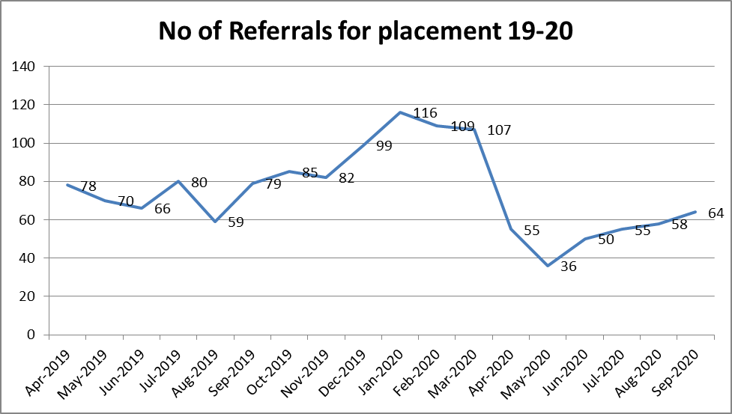

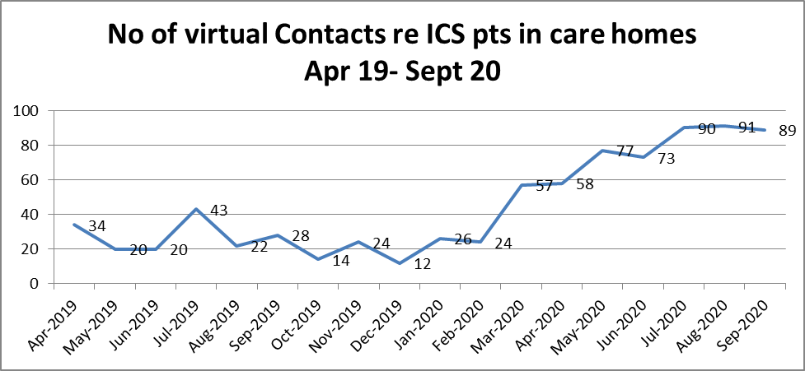

Despite number of placement dramatically reducing at start of pandemic the number of virtual contacts have directly increased

Resources / team
- What did you need to make the change (equipment, budget etc)?
- Who was involved in making the change – did you involve patients and carers?
- Did you use evidence or build on ideas from other trusts or organisations?

Staff member who led this project was unable to complete face to face and so the resource was available for us to use
IT limitations were and remain biggest limiting factor
Mindful of project outcomes shared re use of virtual technology that not everyone is comfortable with same and so telephone/ virtual are offered where face to face is not an option

Key learning
Support for care homes is crucial at present and that we need to find balance between protecting pts, staff in care homes and not allowing the important benefits of rehab to get lost to potentially affect people negatively in the longer term
Good communication with care home staff was key- and choosing times of day to suit care home staff who have their own busy priorities to juggle
If our staff were more comfortable with virtual therapy in advance further progress may have been made

Tips for others
Anyone providing a rehab service, other care homes to share the learning
Make yourself available for the care home staff- it has to be seen as a help/ benefit for them and their pts
Keep the patient at the centre

Contact name: Celene kirrane………………………………………………………………..
Contact email address: Celene.kirrane@southerntrust.hscni.net………………………………………………………………..
Date of innovation / initiative…Apr- Jul 20……………………………………………………………..

Do you have any attachments?
- “A picture is worth a thousand words". Are there any photos or graphics that could help bring your story to life?
- Are there any supporting materials, documents, communications or other outputs that you used or produced that you could share to prevent others reinventing them?
If so, please upload them to the Fab site with this completed template.

