Share your Fab Stuff!

2020 has been tough for health and social care. We want to make sure your fantastic work from the last year is celebrated, and that the learning isn’t forgotten.

We’ve drafted this template to help you structure your story. It’s designed to help others put your learning into practice. Try and complete every field if you can, but don’t worry if you can’t. When you have completed the template, please upload it, together with any attachments, to https://fabnhsstuff.net/login?ral=https://fabnhsstuff.net/upload-your-fab-stuff

Title of innovation / initiative
- The Silver Linings of Covid-19

Problem
- The Trust entered the Covid-19 first wave with inadequate mechanisms in place to record our experience of it.
- As the first few weeks of the pandemic progressed, it became apparent that we risked losing learning from some of the invaluable experiences.

Aim
- The aim was to create a process and mechanism for capturing all the lessons from our response to the pandemic:
  - the ‘good news’ items to help motivate staff in difficult times;
  - the innovations, kindnesses and creativity to both help us through the pandemic and to build into our future business as usual
  - the things we got wrong to learn from, again both for the ongoing and future Covid-19 waves and other incidents, and for our ‘new’ business as usual.

Plan
- The approach started with a simple spreadsheet workbook that rapidly evolved to provide a robust set of information fields, ending up with the following:
  - Unique identifier
  - Source
  - Category:
    - Leadership and Communication
    - Operational Processes and Flows
    - Staff Health & Wellbeing and Support
    - Ways of Working and Patient Experience
  - Description
  - Hyperlink to any supporting information
  - Quality impact (improved, maintained, worsened) with the context of the ongoing pandemic
  - Exit strategy (assumed) – e.g. Retain, Revert, Close, Review with Service, etc. with indication of corporate support required to action the post-pandemic action and ownership.
  - Possible value opportunity (e.g. cost-out, efficiency, productivity, estate)
  - Follow-up ownership and monitoring through existing Trust governance
  - Links to the Trust’s existing, emergent and long-term strategic transformation portfolio
  - Where items could or should link to wider ICS intiatives.

- Silver Linings were collated from a number of sources:
  - The daily Staff Update emails from the Executive Tri, sent via the Communications Team.
  - The twice-daily COVID-19 Situation Report (‘SitRep’) calls.
  - Other direct and incidental emails received, sent proactively by colleagues.
  - Step-up and –down plans created by Divisions in the early days of the pandemic
  - Information on the Trust intranet site
  - The Trust’s Staff Wellbeing and Support Hub
  - The Charity team
  - Various incidental meetings and telephone calls
  - A dedicated Silver Linings email account, in response to a call for any items placed regularly in the daily Staff Update email.

Benefits
- The benefits were varied, ranging from some small cost saving ideas, through to widespread service delivery improvement ideas.
- Perhaps most importantly it ensured that our experience of Covid-19 and our response was recorded and captured to ensure our transformation portfolio is relevant and prioritised.
- Over time a front page ‘dashboard’ was also produced to track items and generate reports.

Measures

Resources / team
- The process was handled at zero direct cost; just someone’s re-purposed time during the first wave of the pandemic.
- No special equipment or budget was required.
- No direct patient carer or public contact was sought as this was an internal management process.

Key learning
- The process and tool evolved rapidly in the first weeks of the pandemic’s first surge; arguably a more dedicated software tool would provide greater benefit over time, including a way for staff to record items directly through an intranet page or app.
- We learned that just being involved with our response to the pandemic was a reward in itself, but that doesn’t come without cost. ‘Thank you’ goes a long way though.
- There is a wealth of information and implications from some of the most simple ideas, and people have a genuine need to be heard in their area of work.
- We (re-)learned that people have an immense sense of ownership and pride in the service they provide, whether clinical or corporate, at all levels. Covid-19 has confirmed more than ever the sense of ‘My NHS’.

Tips for others
- We would be happy to share the approach and template with other organisations.

Contact name: ………………………………………………………………..
Contact email address: ………………………………………………………………..
Date of innovation / initiative: ………………………………………………………………..

Attachments

% of items by top-level category
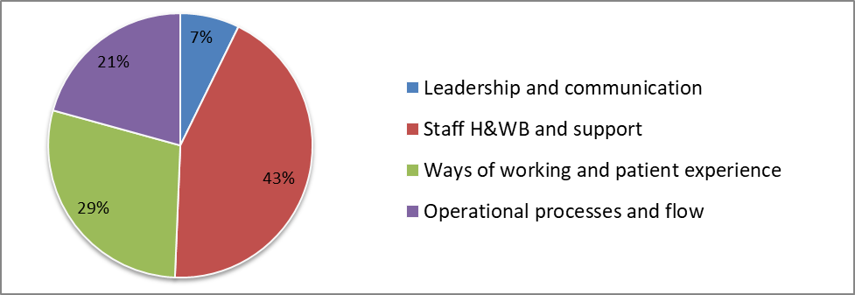

Number of items by handling/exit assumption
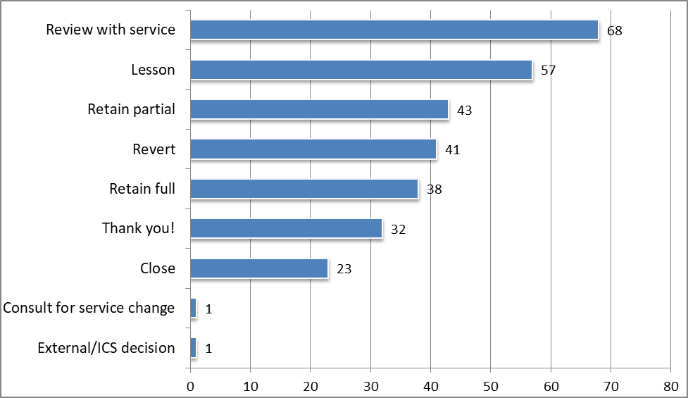

Number of items by follow-up ownership




