Deliberations of a Disordered Mind
Rachel Symons

A teaching resource that describes the lived experience of mental illness.

“Still like air, I rise.”
Maya Angelou
Contents

 | ACKNOWLEDDGEMENTS | 4
 | INTRODUCTION | 5
1 | The Cautionary tale of Mr D (Depression) | 7
2 | Change (Anger) | 9
3 | Breathe (Anxiety & Self Harm) | 10
4 | Nothing (Dissociation) | 11
5 | The Expedition (Personality Disorder) | 12
6 | What’s Reflected? (Eating Disorder) | 14
7 | Demon Nights (Insomnia) | 15
8 | Return to Default (The legacy of abuse) | 16
9 | The Edge of the Abyss (Suicide) | 18
10 | Hope (Recovery) | 24
 | References | 25

Acknowledgements
Evidence shows that poor experiences in childhood can lead to poor mental health (ACES too High, n.d.; Gerhardt, 2004; Perry & Szalavitz, 2010; Perry & Szalavitz, 2017; Van der Kolk, 2010), but it’s hard to quantify why some people cope better than others. Bruce Perry argues that children who experience abuse and neglect in the first year of their lives, regardless of whether that abuse then stops, have poorer outcomes than those who have a loving first year, then for whatever reason, experience abuse after this, even if that abuse lasts for many more years (Perry & Szalavitz, 2010). That is to say that the first year of life is so crucial in terms of brain development, that disruption at this point causes longer lasting damage.
What is clear is the power of love (Gerhardt, 2004; Perry & Szalavitz, 2010; Perry & Szalavitz, 2017; Van der Kolk, 2010). Through reading widely around the subject and through personal experience, I believe that love and care is crucial to both recovery and to the development of resilience, that is to say, it is the pockets of love and affection that children experience during and after the abuse, that make the difference. “Just as a traumatic experience can alter a life in an instant, so too can a therapeutic encounter” (Perry & Szalavitz, 2017).
“I’ve had so many rainbows in my clouds; I’ve had a lot of clouds, but I’ve had so many rainbows. One of the things I do when I go to step up on stage, or I go to translate, or when to teach my classes … I bring everyone who has ever been kind to me with me … so I don’t ever feel I have no help. I’ve had rainbows in my clouds. And the thing to do, it seems to me, is to prepare yourself so that you can be a rainbow in somebody else’s cloud.” (Angelou, 2013)
Rainbows in my cloud:
Daniel, my beautiful, amazing, caring, talented and unique son who has saved me more times than he realises. My absolute world.
Angie, foster mum and friend has provided love, reassurance, advice and care for nearly 30 years, without which, I doubt I would be at the point I am now. I know I don’t say it enough, but thank you, I really do appreciate it.
Helen, Rachael and Wendy, best mates who have held my hand and propped me up when I’ve been at my lowest.
The Rocky Crew, particularly Ann, Ann and Mary who have been substitute mums during some extremely difficult times.

This list is not exhaustive, there are many more people who have helped me along the way. If you’ve been one of them, thank you.
Introduction
This booklet has been written to help give the reader some insight into what it feels like to experience some of the conditions, your patients will present with.
As will become evident from the content of some poems, I have experienced abuse, both as a child and, as is often the case, as an adult. The lasting legacy of this has been struggles with my mental health, particularly depression and anxiety. As a child we internalise the way in which we are spoken to and treated, this then becomes our ‘inner voice’, or conscience. If a person experiences a positive and supportive childhood, unless disrupted by a major trauma, they grow up with more confidence and self-esteem, the internal voice telling them ‘I can’ rather than ‘I can’t, or ‘I deserve better’ instead of thinking ‘I deserve to be treated badly.’ As with most people who have adverse childhood experiences (ACEs), I have a persistent negative internal voice, one that has grown in intensity throughout adulthood as a result of further trauma. Whilst it never changes its content, of telling me what an abject failure I am, and will always be (even though I know logically that I’m not), it accumulates evidence to confirm this belief (described in ‘The Cautionary Tale of Mr D’).
This repetitive monologue (described in ‘The Expedition’), when I am in good mental health, is at a volume and intensity of 1 or 2, meaning that I can ignore it, laughing at it or shut it up by telling it to go away. When I am at my worst and it is a 10, it is ever present, it drowns out all of my own thoughts telling me how useless and pointless everything is. During the day time, most people would never know as I manage to block it out by working extra hard making me the perfect employee as I’m super productive - I can’t stop otherwise it allows the monologue to take over. However, at night (‘Demon Nights’) it is harder to block out and it refuses to shut up or go away, persistently telling me how much better everybody’s life would be without someone as useless and pathetic as me dragging them down (and yes I know that’s not true). When I am at this stage, at night, coping strategies simply don’t work.
Thankfully as I learn more about neurology and mental health, I am able to rationalise and deal with these intrusive thoughts better; in effect I become my own counsellor and am able to talk myself down through using my knowledge. I am fully aware of why I am like why I am, and I am also aware that I am lucky to have the intelligence to learn and understand the basics of how the brain functions which enables me to make the necessary links. I am also fortunate to have the ability to write creatively, which has become a big part of my coping strategy.
I debated whether I should make public something as intimate as my thoughts and feelings from times when I have been unwell, people might use it to judge me, think I’m ‘crazy’, or believe I am unsafe to practice as a mental health nurse or to work with children. This is the nature of the stigma of mental illness - nobody would worry that a nurse with asthma would be unsafe to work in an asthma clinic, or a nurse with diabetes was unfit to practice on a ward, we would presume that the condition was managed causing no concerns about their nursing ability. The same is true with mental health – predominantly, symptoms are managed; the more you live with a disorder, the more skilled you become at recognising the triggers and signs of relapse, hence the better placed you are to respond. As with physical health conditions, there will be times when you are naturally more vulnerable, it is at these times, it is critically important to be self-aware and put in place as many preventative measures as possible, just as you would for a condition like asthma, where you would make sure you have your flu jab for example. [NB: If I keep comparing to asthma, it’s because I have asthma so can relate, not because I have something against asthmatics!!]
I firmly believe my experiences make me much better, not worse, at what I do; they are the driving force behind my passion and motivation, and they give me far greater insight and empathy for others struggling to cope. That is not to say that I think everyone who experiences poor mental health will experience it in the same way as I do, they don’t, but I can certainly empathise with the confusion, frustration, anger, fear and hopelessness mental illness can bring.
I am fortunate that I have the skills and ability to verbalise mental illness, hence I provide a voice to those who can’t. If my experiences can help inform and give insight to people working in health care, then that is a positive. If by describing my poor mental health, I can be one more voice challenging the ever-present stigma, then that is a positive. If writing about my thoughts and feelings can help someone identify and feel less alone, then that is yet another positive, therefore I see no reason not to write or share.
I refuse to be ashamed of my past or my mental health, it has made me stronger, kinder and more empathetic than you can possibly imagine.

The Cautionary Tale of Mr D
Depression

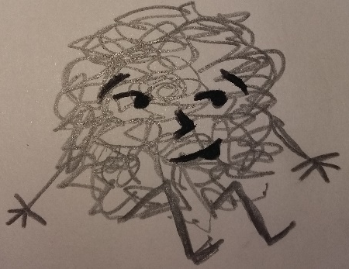
This is the cautionary tale of, old Mr D,
Or depression, as he’s known to you and to me.
He squats beside ‘memories’, inside of your brain,
Silently waiting to cause sorrow and pain.

Old Mr D is a bullying tormentor,
Who feeds on bad memories right from the centre,
Of your brain; things long since forgotten,
He stacks them and stores them, he files and records them.

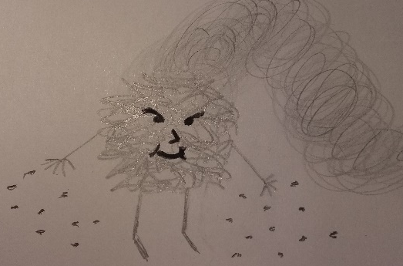
He lurks until times get a little bit tough,
Then like a snake, he sneaks out from the rough.
A toxic fog, he creeps through your brain,
Worming and squirming till you feel insane.

He throws out his seeds, they quickly take root,
Turning good into bad, and bright into soot.
He slows down your thoughts, makes everything dull,
Bad memories resurface, good becomes null.

Things that had been, that you’d rather forget,
He shows you the picture, then watches you sweat.
Humiliation, fear, regret, guilt and shame;
Mr D grows fat on your feelings of blame.

What is the point? I’m stupid, I’m fat,
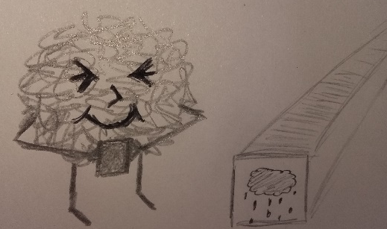
I’m ugly, pathetic, useless, a brat!
Things can’t get better, these facts, they are certain,
Nobody likes me, I’m a horrible person.

But these thoughts are not facts, they’re not even yours,
They belong to another; whose voice is a roar.
Mr D, he grows stronger, feeds on all that is bad,
Seeping through thoughts, twisting happy to sad.

Is that the end of this sad tale, you wonder?
To tell of such sorrow, surely a blunder!
Mr D, I agree, he’s a spiteful, mean creature,
Why tell of a sorrow that makes life so much bleaker?

It’s true that the tale I tell is most sad,
But not telling about him, makes Mr D glad.
If you don’t know he exists, his power is legitimate,
And leaves the sufferer in an awful predicament.
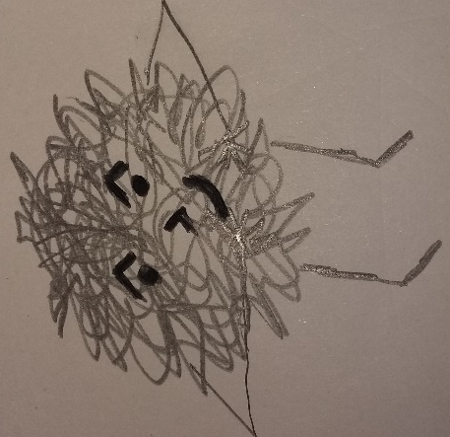
You see there’s an antidote to Mr D’s power,
But first you must see that it’s HIS thoughts that flower.
He’s wrong when he says that you’re stupid and fat,
You’re not, you’re not ugly, not useless, or a brat.

These thoughts make you want to hide, not to walk,
Tall with your friends, afraid people will gawk,
Afraid that they’ll guess, you’re a failure, a fraud,
But the antidote to Mr D’s power is to … TALK.

Keep Mr D’s thoughts to yourself and they’ll grow,
Leave you playing the villain, your true thoughts all froze.
But talk to your friends, they’ll tell you the truth,
Not perfect, they know, but his lies they’ll uproot.

If a friend’s not available, then talk to a teacher,
A parent, a doctor, a help line, a preacher.
The more that you talk, the more you will see,
The lies Mr D told are really quite beastly.

And as you talk, a curious thing happens,
Mr D starts to shrink, his grasp on thoughts slackens.
The fog that once had made thinking all fuzzy,
Slips softly away, the day break is sunny.
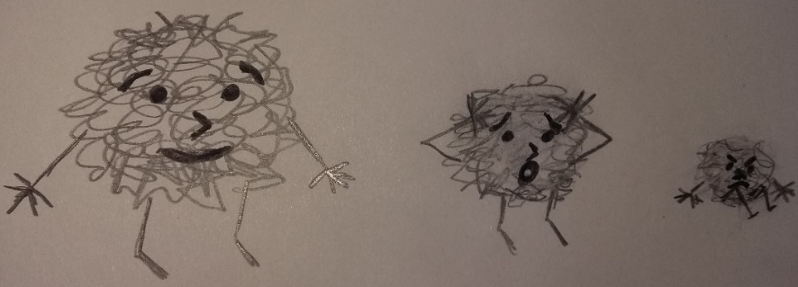

Change
Anger

A rage curses through my veins,
Contaminating futures by evils long since past.
Futile attempts to get a grip and take hold
But like the sands of time, it flows deftly through.
Injustices old spring to injustices new,
Fortress walls prevent access to a
World of green, of privilege unseen,
Not for the likes of us. A species apart.
Ours is red, the other side of the
Impenetrable bricks, keeping out the talent
And the gifts of a beaten down tribe,
Of a people old before their time.
But when those same people join as one,
Rise as one,
move as one,
that same colour red swirling into mist,
becoming a whirlwind,
creating a hurricane,
seeping through the mortar
of a crumbling institution.
When that rage erupts
The curse that had held in place
Loses its power,
The very foundations begin to shake.
A new creation is about to shape,
To form into a vision created by
Talents honed on the hard, cold rock of indifference.
Anger is predominately seen as a negative emotion as its power can be extremely destructive. It is important to realise that it’s okay to be angry, that it is a natural emotion that comes when we perceive we have been wronged. The key is how we manage it. Anger can be an enormous power for good if it motivates us to work to change the things that have created such intense feelings, and if it is expressed in the right way to the right people.
This poem started off expressing feelings regarding something specific, but grew into something bigger as I realised I was angry about a general system that seems to disadvantage some more than others. I have two main passions, education and improving mental health, something I have combined in ‘Thriving Futures’ mental health resources for schools. I deliberately keep my work free as epidemiology shows it is the young people and schools in the most deprived areas that are most vulnerable to poor mental health, particularly those in the care system. This is my way of managing anger at a system that arguably fails some of these young people.

Breathe
Self-harm
Scratch, screech, drip, useless.
Can’t breathe,
Scratch, screech, drip, useless.
Feel sick. Pathetic.

The silver point of a hard, cold blade,
Scratchscreechdripuselesspathetic.
Presses deep into the soft relenting flesh.
Scratchscreechdripuselesspathetic.
Blood trickles across clammy skin.

A welcome sting, that brings relief.
A mark to demonstrate the pain.

Silence.
It’s okay to

Breathe again.
For now.

Imagine.
A deep and searing pain,
No mark to act as proof,
No swelling or temperature
Or sickness or heat.
No sign of any kind.
Fraud.

Inside, the pain is constant,
It’s one that can’t be described.
Nails scratching across an everlasting blackboard,
The incessant screeching of a wheel,
A tap dripping into an empty tin pot,
The echo rebounding as in meets the next,
Drip, drip, drip. Unrelenting.

All played out together,
As the vice like grip
on the exhausted brain
Gets tighter, scratch,
And tighter, screech,
And tighter, drip.
Unceasing.
It can be difficult to understand why someone may deliberately want to hurt themselves, resulting in some people concluding that it is attention seeking. Whilst there are many reasons for self-harming, the one common link is a maladjusted coping strategy, one that requires empathy and understanding.
The poem describes the build-up of anxiety that has led to past self-harming. This will not be the same for everybody, but hopefully it will give some insight as to why a person feels the urge to do physical damage to themselves. Whilst I still experience the feelings described, thankfully, with increased understanding and better coping strategies (writing being a big one), I have found more healthy ways to manage the distress described.
Scratch.
Unremitting.
Screech.
Unending.
Drip.

Disjointed thoughts,
Invade the mind,
March rough shod
Over all original thought,
Stirring up memories, doubt,
Useless, useless, USELESS.

As the vice gets tighter,
Scratch, screech, drip, useless.
A boa constrictor suffocates the chest,
Scratch, screech, drip, useless.
Gets tighter,
Nothing
Dissociation

A glass wall surrounds me.
Trapped in a vacuum of nothingness.
The daily actions continue as before
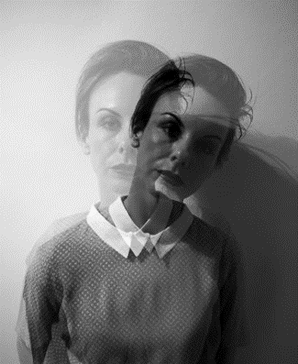
But they are nothing, they mean nothing.
The actions are robotic,
The feelings elusive.

I have become a mannequin,
An empty vessel who no one sees or regards.
A blank face in a nameless crowd
Of no more significance than
Yesterday’s torn up newspaper
Floating on the wind.
Redundant.

If I sit still enough,
Maybe I will
Become a statue.
(Grusovin, n.d.).
Maybe I
I will
fade
away.
Dissociation is often a response learnt from trauma in which it was impossible to fight back or run away – the brain’s only option to cope with the trauma was to remove itself.
Many people describe dissociation as leaving their body, floating up and watching the trauma from a distance. For some people, they describe going to a ‘safe place’ totally away from the scene (Perry & Szalavitz, 2010).
This is why people who have experienced trauma may be totally unable to remember it, and if they do, they only remember snippets rather than the full story.
My experience of dissociation is feeling my body becoming heavy and sinking out of it into the sofa, bed or chair, hidden and safe but numb. At that point it’s possible to do or say anything to the body that remains, because Elvis has left the building!
The main problem is, that once this response has been learnt, the brain will often use it to cope even when it’s inappropriate, leaving the person feeling confused, frightened and numb.
Become
Noth

The Expedition
Personality Disorder
Strange. A creature, so at home yet so out of place.
A feral cat squatting, skittishly belonging,
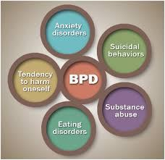
Yet also belonging to a separate race.
A melancholic look of yearning, of longing,
Eager to disguise the need to embrace.
Desperate for attention, for loving protection,
Yet choosing the cold hand of those who debase.

Seeking brutality,
carnality of the blade, hungry for flesh,
an insatiable need for
skin to bleed,
for pain to take hold
to smother the senses, drowning
(Meta media news, n.d.)
out all past, all future,
to booster,
the here, the now,
away from the torture
of past trauma
a never-ending, never-bending, ever pending loop of
persistent persecution, excruciating endorsement, of
worthless, useless, hopeless, helpless, pathetic waste of fucking space.
Revealed in a stare of impenetrable ice,
Stand back, stay away, the message concise.
This poem was written in response and reflection after difficulties communicating with a young patient diagnosed with borderline personality disorder (BPD).
Research shows a strong correlation between childhood trauma and diagnosis of the disorder (Gerhardt, 2010; Van de Kolk, 2014). In the poem I attempt to show the impact this has on the patient’s ability to trust and on future relationships, in addition to the complexities this presents creating a therapeutic relationship.
I have annotated the poem below to further demonstrate the mistrust and obstacles that will need to be overcome.

Crossing the gulf of the gargantuan chasm,
The few short steps, a whole expedition away.
Eyes watch with suspicion, with knowing sarcasm,
Heckles raised and hissing, claws ready to slay.

Alliteration using sibilance creating hissing sound – ongoing through poem. Words emphasise transitory nature & not belonging.

Suggests something new or looking at something different to the norm.
Title suggests a difficult journey. Language linked highlighted in brown throughout.
Described more as an animal, rather than person. Words highlighted in purple hint at failure to fit in.
Feral, suggesting past neglect.
The Expedition
Strange. A creature, so at home yet so out of place.
A feral cat squatting, skittishly belonging,
Yet also belonging to a separate race.
A melancholic look of yearning of longing,
Eager to disguise the need to embrace.
Desperate for attention, for loving protection,
Yet choosing the cold hand of those who debase.

Seeking brutality,
carnality of the blade, hungry for flesh,
an insatiable need for
skin to bleed,
for pain to take hold
to smother the senses, drowning
out all past, all future,
to booster the here, the now,
away from the torture
of past trauma,
of a never-ending, never-bending, ever pending loop of
persistent persecution, excruciating endorsement, of
worthless, useless, helpless pathetic waste of fucking space.
Revealed in a stare of impenetrable ice,
Stand back, stay away, the message concise.

Crossing the gulf of the gargantuan chasm,
The few short steps, a whole expedition away.
Eyes watch with suspicion, with knowing sarcasm,
Heckles raised and hissing, claws ready to slay.
Extending metaphor of lack of belonging
Feral cat, suggesting an animal that looks harmless but could be dangerous due to distrust of humans. Use of sibilance highlighted in red throughout poem to create ongoing hissing/ warning sound throughout.

Use of contrast highlighting the conflict of desire vs reality.

Words in green show violet/ destructive language or imagery, mirroring violence & destruction of self-harm.

Repetition of ‘yet’ emphasising contradictions of BPD

Group of 3, repetition, alliteration, long lines and violent language revealing the extent of self-disgust.
Imagery of violent death – linking to violent language, revealing normal senses are comparable.

Words in blue demonstrate feelings of helplessness. Increased use of sibilance as poem focuses on the negative feelings of the patient.
Metaphor showing mistrust and hinting at the difficulties in creating a positive relationship. Links to imagery of ‘cold’ from stanza 1. Rhyming couplet ‘locks in’ the negative feelings, keeping help away.

Language/ imagery/ alliteration highlighting how difficult it will be to reach this person.
Extending metaphor, contrasting of distance of room to epic journey required to create a connection with this person. Links to title.
Alliteration emphasising lack of trust.
Imagery of a trapped, frightened animal, links to first stanza, ‘feral cat’ and sibilance used throughout to demonstrate hissing.
Use of violent language again highlights the potential danger this person poses to self and nurse.
Onomatopoeia reinforcing sibilance used throughout poem.

Structure: Stanzas 1 & 3 represent the nurse’s perspective, thus have a regular rhyme, rhythm and structure. Stanza 2 represents the BPD patient thus has no rhythm and a random rhyme structure to represent unpredictable emotions and behaviour. Enjambement is used throughout stanza as lack of full stops creates a sense of confusion and reflects the ongoing, never ending nature of this state of being for someone with a PD. Sandwiching this between stanzas with regular structures emphasises the contrast between the state of being of the two people, thus highlighting the difficulties of communication between the two. It is also a representation of support surrounding the patient, or the patient’s feelings of being trapped (echoed by image of feral cat), dependent on perspective.

What’s reflected?
Eating disorders
What is in a reflection?
The more the size reduces,
The greater, will to disappear,
To not take up any more space,
In a world now filled with fear.
The reflection was never about the size,
Although that became the focus,
The hate was always about the self
And the feeling of being worthless.
Because this isn’t about a diet,
It’s not even about the food,
It’s about feeling never good enough,
About a crushingly low mood.
It’s not really about the body shape
Or the image being reflected
It’s ‘bout a mind that has been damaged
A person that has been dejected.
A past history of no control,
From when and where, it matters not,
What matters now is learning to love,
The real person left to rot.
When looking for measures of success,
Or where to set the bar,
Remember images can never reveal,
The worth of who you really are.
What does it reveal?
Can the image staring back,
Reflect what’s really real?
The face, the eyes, the body,
Is that the sum of all we are?
Or is there, should there, always be.
A greater measure to set the bar?
And if the image imperfect?
The stomach far from flat?
The face not pretty or handsome enough?
Does that make the whole person trash?
And what if, when you start to stare,
The image becomes distorted?
What if the only thing that’s worth a toss,
Is a body shape contorted?
And if the level of bone protruding,
Becomes the measure of success?
What then for the person trapped inside?
For a mind locked in distress?
The real person shrivels,
Consumed by guilt and shame,
Food becomes the enemy,
And it’s weight that takes the blame.
The neglected body becomes a mask
I struggled with an eating disorder when I was younger, and whilst that is no longer the case, my eating is still sometimes disordered, especially in times of high stress, where I struggle to eat. A common misconception is that eating disorders are just about weight and size, in this poem I attempt to show that this is not the case, they are merely the symptoms of a mental health disorder that is predominately about trying to regain some sense of control over feelings of guilt, shame and worthlessness.
For the tidal wave of hate,
The dark deep-seated loathing,
Has already sealed the fate.
The weight ever descending
The clothes size still diminishing
Presents illusion of tight control,
But the real person’s dwindling.

Demon Nights
Insomnia
For many people who struggle with their mental health, night times are hard; without the distractions of the daytime, it can be difficult to block out all the unwanted thoughts and memories that flood your mind. I have to be honest and admit, I’ve yet to find a solution for this one.
I’ve tried many things, listening to music, listening to ‘white noise’, distracting myself by doing sums in my head (I hate maths), playing ‘I went to the shops and bought …’, reading, all sorts. I don’t have insomnia all the time, stress is the main trigger, but once it starts, it tends to last from a couple of weeks to a couple of months. At times, when it won’t clear, I need to speak to the doctor to get some tablets to ‘reset my system’ as I put it; there’s no shame in that, no more than an asthmatic needing the occasional course of steroids when struggling to bring a brief deterioration in the condition, under control.
On a positive note, some of my best and most creative ideas come at around 2 o’clock in the morning, so swings and roundabouts and all that!!
Nights lie heavy,
Demons swarm the air,
Thick, dense, predatory.
The victim sits still, frozen,
All defences destroyed by
the weight of the day.

Unseen the ghoulish
gathering prepare,
Drinks opened
As the anticipation of
A night’s mischief heightens.

Every night the same,
The air thick with expectation,
Malevolent intent.
The time will soon be right.
They know it, the victim knows it,
The ritual well established.

Head touches the pillow.
The gate opens and
The swarm enters.
Let the party commence.
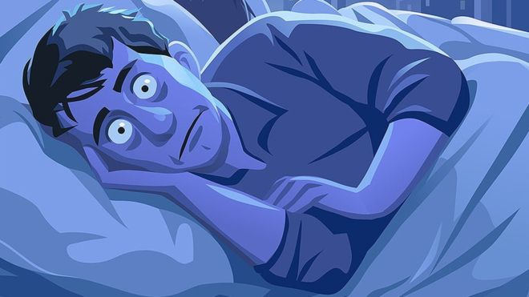
Getty Images
Return to Default
Legacy of abuse

Background
I wrote the following poem to demonstrate the long-term impact that abuse can have due to the internalisation of ill-treatment.
I often describe my ‘default setting’ as ‘worthless piece of shit’, hence the title of the poem, in which the roots of this crushingly low self-esteem are revealed. It is worth noting that the inaction from people around me who must have suspected what was happening but did nothing, compounded the problem as it confirmed that I wasn’t worth saving, hence the abuser/s were right, and I ‘deserved it’. Consequently, as an adult, if I suspect ill-treatment, I will report it and would urge the reader to do the same. It does not mean you are making a judgement, you are simply passing on information you have to the relevant authorities, which may just be the final piece of a puzzle.
Whilst I am able to use logic to understand that those thoughts are not true and that thinking them doesn’t make them so, it does not stop them from occurring or the distress they cause, resulting in an internal monologue like the one described in ‘The Expedition’, or constant vitriol represented in ‘Edge of the Abyss’
Increased understanding of the impact of abuse, on how the brain functions has helped me manage such thoughts, releasing the ‘real me’ described in the final stanza, but experiences over which I have little control, or which are unpredictable, have the potential to ‘Return to Default’, and so the process has to start again. This is why it is so important that organisations become trauma informed as such thoughts and feelings do not go away when the stressful period ends, they continue, and much effort is needed to gain control of them again.
NB: The abuser referred to in the poem is not just one person, rather the amalgamation of a number of different people.

Return to Default
Legacy of abuse
I know I hate me.
Too loud, too brash with a mouth that won’t shush
“Shut up you bitch, no one’s interested in your stupid stuff”
Too arrogant, too rude, too desperate to prove
“Never amount to anything, too thick to improve”
I know I hate me.
Always on the outside, never truly belonging
“Get up to your room, not welcome, stop stalling.”
“Don’t deserve, not good enough, a total waste of space,
Too greedy, too selfish, a fucking disgrace.”
I know I hate me.
Desperate to be alone, stop people getting too close
“Who’d want to be friends with someone so utterly gross?”
“Who’d want to lie with a thing of your size and shape?
Can’t even look at you to fuck!” Don’t, you mean rape?
I know I hate me.
Too compliant to fight, just praying you won’t appear,
Lying silent in the dark, immobilised by fear.
Doing as instructed, won’t pay to make you angry,
Instead of responding, I just stare at you blankly.
I know I hate me, I even know the reason.
Hating is safe, it protects what’s inside,
It keeps closed the barrier, all feelings have died.
Too dangerous to trust, “pride is a sin”
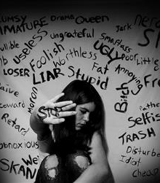
Better off alone than to let the wolves in.
I know the real me remains locked up and hurt,
I know she is waiting, needing love to reverse
Past damage that was caused, bring to the here and the now.
I know I need change. What I don’t know is … how?

The Edge of the Abyss
Suicide
Background
Death by suicide is perhaps one of the hardest for those left behind to cope with, creating all manner of emotions in addition to the grief that comes with the death of a loved one. Many people believe suicide is a selfish act of cowardice, how else do you explain someone choosing to end their own life, knowing the impact this will have on those around them. But therein lies the problem, suicide often isn’t a choice, the individual is not thinking, they can’t think, in that moment, they have no access to the part of the brain where rational decisions are made; they are reacting to the overwhelming pain and confusing taking place in their head.
People go to Switzerland to end their life when they are suffering from a physical illness that has become too much to bear, family often support this, and many argue that euthanasia should be made legal in this country. If someone was in prison being tortured every day with no hope of release, no one would blame them for ending their life, they’d understand and wonder whether they would do the same thing. Mental illness can be like torture, unrelenting, every moment of every day, creating a pain that is harder to bear than anything physical (described in ‘Breathe’). The difference is, it can’t be seen.
I liken depression to being stuck on a conveyor-belt that is carrying you, at various speeds, to the edge of an abyss - just to stay in the same spot requires effort. Sometimes the speed of the conveyor-belt increases and the person can no longer keep up so they start to fall behind (deteriorate). Other times, the effort required just to stay in the same place is too much, so they stop which allows the illness to consume them and they rapidly go down-hill. At the end of that conveyor-belt, is the end point of depression, the final most devastating symptom, suicide, although the individual will journey through many other stages on route, including suicidal ideation, which is what it says, having ideas or thoughts of suicide.
Without wishing to sound dramatic, I have lived with suicidal ideation for decades, that doesn’t mean that I want to kill myself every day, I don’t; or that I am at risk of harming myself, I’m not; what it means is I have often thought the world would be a much better place without me (even though I know logically it wouldn’t), or at times, I get tired of having to run on my conveyor-belt just to keep time with everybody else’s walking. It means I notice when there’s a steep drop and wonder if it’d be high enough to kill you, or I think about whether I would have the guts to jump, or I notice if there’s a gap in the fence leading to the train tracks or … It doesn’t mean I have any intent on doing any of these things, I don’t – I have a beautiful son who is my main, and sometimes only, ‘protective factor’, but knowing these things could be an option is enough, it provides a sense of security by providing a potential escape route.
The following incident occurred after a number of major stressors, ones over which I had had no control, snowballed, resulting in huge disappointment and betrayal taking me right to the very edge of my conveyor-belt. These stressors would have been difficult for anyone to deal with, but for me, they triggered a trauma response stemming from abuse (described in ‘Return to Default’). By the time the incident took place, I had been living in a perpetual state of hypervigilance (described in ‘Breathe’) for over 4 months, the only time that state stopped was when I dissociated (described in ‘Nothing’) or when I was asleep often experiencing night terrors. It was very much a case of the proverbial straw.

The Edge of the Abyss
It is dark, I’m walking up the road, thankful that the pockets in my coat are large enough to hold a bottle of wine. I don’t know where I am going, only that I am out of the house; I had had to get out of the house, it had become too claustrophobic in its inability to contain the weight of my distress and disappointment. I had needed room to breathe and space to think.
I walk, head down staring at the pavement, orange light from the street lamps distorts as it reflects in the rain soaked tarmac. I gulp the wine as I try to make sense of recent events.
‘It must be me,’ I reason.
‘Of course it’s you, you stupid bitch, no one’s every going to listen to you because you’re a worthless piece of shit, a nothing.’
Music booms full volume out of my earphones, and I try to focus, follow the melody, listen to the words, anything to cut out that negative inner voice that has been a part of my life for almost as long as I can remember.
‘You’re a nothing, a nobody, nobody wants you.’
I continue to walk, head down, grateful for the cover of the night, that nobody can see me and that I don’t have to talk. I don’t want to talk. I want to think. I need to think, need to work out why nothing I do, no matter how good my intention, how hard I work, why nothing ever works. There has to be a reason, has to. Maybe it’s me, maybe I deserve it.
‘Of course you deserve it you stupid bitch, such arrogance to think you’ll ever amount to something. You make a difference, don’t make me laugh.’
Maybe it’s all my fault, that I’d been kidding myself and everything had always been my fault, everything.
‘Of course it’s your fault. You’ve never been worth anything, you’re an ugly, stupid, waste of space. You deserve everything that’s ever happened to you. Shit happens to shit.’
My head feels as though it is about to explode, that someone has got it in a vice and has turned the screw so tight that something has to give. I bang my head, hard, an attempt to stop the thoughts. It doesn’t work.
‘You’ve always been a pathetic waste of space, no one has ever wanted you. I told you you’d never amount to anything. All these grandiose ideas; you’re a stupid fuck, nobody wants you, nobody cares.’
In my mind I reply, I know there’s no point, that these thoughts won’t stop, that arguing will make it worse, but I can’t ignore it anymore, ‘You’re wrong, I’m not worthless, people do care, I can make something, I can be someo..’
‘Who the fuck are you trying to kid? You’re nothing, always have been, always will be. You can’t win, ever, because you’re a stupid little bitch. You’re a burden, a miserable pain in the arse who only ever causes trouble.’
“FUCK OFF!” Did I say that out loud? Shit. I look around to check nobody has heard, then I drink.
Am I drunk? I’m not sure, probably am, must be in fact, I’m half way through the bottle, I’d normally be drunk by then. I don’t feel drunk. Maybe what I mean is that I don’t feel any better, that the alcohol is not easing the pressure of the vice clamped on my head which continues to get tighter; a sadistic medieval torture device. Why won’t it stop? I punch the wall in sheer frustration.
‘Is that it, that the best you can do? Even that’s pathetic.’
I punch again, this time harder. And again.
‘Fucking useless, you wimp’.
I punch again, hard, this time with the other fist, soft smooth flesh against hard rough brick, scraping skin from the knuckle, swelling starting almost immediately. Right now, it doesn’t hurt, not much anyway, not compared to the pain in my head. Maybe it’s the alcohol. I continue to drink, continue to walk, head down, ear phones in, music blaring. No plans, no direction, just darkness and walking…
…Did I know where I had been heading all along, maybe I had, somewhere inside? I had thought about ending up here so often, hours… no, nights spent arguing with that bastard voice about coming to this roundabout, perhaps it was inevitable. I stand on the bridge and look over the railings, I only want to look, to stare into the abyss, six lanes of the lights screaming down, in a hurry, always in a hurry. Why is that? Where are they off? Friday night, back to play happy families for the weekend no doubt. Staring, thinking, imagining, I feel safe. In the topsy turvey world my life has become, being here, bottle in hand, chin resting on the cold wet metal of the railings, it feels safe.
‘Bitch.’
There’s a way out, I don’t need it.
‘Useless piece of shit.’
But just knowing it, makes it better.
‘You’d never jump, coward.’
I can imagine it, fantasise about a world with no more worries, no more chest crushing anxiety.
‘Be good riddance to bad rubbish.’
No more feeling of pending terror.
‘Go on, I dare you.’

Fuck! A bastard car has stopped. Fuck, go away, go away, please, I don’t want to... Oh thank God, he’s just at the lights.
I wonder, how far down? Would it hurt? What if you landed on top of a car?
‘Coward.’
Poor bastard driving it, you’d never get over that would you? What if you actually killed the driver? What if …
‘told you, you pathetic piece of shit’
… if it caused a huge crash? No, just want to look. Just want to think, to imagine.
‘Shit happens to shit.’
Oh fuck, that car’s still there. The lights have changed, everyone else is moving. Why can’t he just go away? Shit. Need to think. Fuck.
‘Can’t even do this right can you? Stupid bitch.’
Shut up, I need to think, need to… Fuck!! I don’t want to talk, I don’t want to jump, I just want to be. Why won’t he go? Bollocks, the hazards are on. Fuck, I’m going to have to move. Shit, why can’t people just mind their own business?
‘You hypocritical bitch, you know you’d stop if it was the other way round, you pathetic do gooder, see, people don’t want you or your meddling …’
I drink, hard. “Shut the fuck up, you bastard.” I’m speaking out loud, and I don’t care. Past the point of caring.
I walk. Daren’t turn around.
‘Get to your room. No one wants you here.’
Don’t want to know if someone has got out. Maybe me walking will keep them happy, maybe they’ll move on.
‘Ugly cow, no one will ever want you, you make me sick just looking at you.’
Maybe they’ll drive round to check I haven’t gone back. Why can’t people mind their own business?
‘The trouble you cause, you’re doing it on purpose aren’t you? Aren’t you eh? Trying to make me angry you stupid fucking bitch. Humph, nah, you’re not even worth the effort’
‘Fuck off, please, just fuck off, you’re wrong, you’ve always been wrong, I am worth … ‘
‘Really, they’re laughing at you, laughing! No one’s ever going to listen to you because you’re a pathetic piece of shit and no one cares’
‘… worth something, I will be something, I’ll prove …’
‘No you won’t, because it doesn’t matter, you can’t win, you can never win.’
‘… I’ll prove it, one day, I’ll… ‘
‘You won’t and you can’t because you don’t matter, you’ve never mattered and never will.’
“Fuck you.”

I’m still walking, except I’m not, well not consciously anyway, I’m lost in a pointless argument that can never be won. Then there’s lights, so many bright lights, I have to close my eyes, but I’m still walking, I can’t stop. It’s like I’m on a travellator, the ones you get at the airport, but I don’t know how to get off. So I drink. And I sway. And I close my eyes, too many lights. Then I realise, that bastard voice, it’s gone. And it’s bliss. And the vice, it’s loosened, my head feels free, light as air; the persistent, never-ending ear-piercing screeching that accompanied every action, every thought, for the past four months has gone. And everything is surreal, everything. Like when you put your head under water in the bath and you can’t hear anything, you know it must still be there, but at that exact moment in time, you’re cocooned, cushioned against it. And it’s bliss.
I walk, eyes closed, not wanting to leave this strange sanctuary. Then a thought, a few steps to the left, and this could be it, forever. No more useless, worthless, pathetic, hopeless, helpless, fat, ugly, good for nothing, stupid, thick as pig shit, mother fucking waste of utter utter space. No more. Gone. For good. Good riddance to bad rubbish. Shit happens to shit. If I turn my back, I wouldn’t even see it coming. Nothingness. Bliss.
But the tiniest fragment of me is still here, clinging to life. I can’t do it, I want to, but I can’t. But I don’t want to leave here, don’t want the thoughts, that incessant scathing voice to return. I decide, I’ll tempt fate – I’ll walk, see how far I can get. I know the police will arrive at some point, but maybe, just maybe, fate will do its job and I won’t have to take that final step. And so I continue, walking, swaying, drinking, in an empty void of nothingness, travellator continuing to transport me ever closer to the edge.
Then a colour… orange… a beacon… beacon of hope… don’t be stupid… no hope left, not here anyway. But it’s definitely there, orange… the SOS phone… why are they still here? Doesn’t everyone have a mobile phone now? Obviously there for dickheads like you walking drunk down the motorway on a dark rainy night… shit… dawning realisation… I’m on the motorway. I’m drunk and I’m on the motorway. You dickhead, what the fuck are you doing? Then a thought, in the midst of that chaotic lonely sanctuary, a thought, just one, one that has saved me millions of times over for the past eighteen years, my son.
The head comes out of the water, the sounds swoosh back, thoughts attack like a swarm of wasps, each one repeatedly leaving its sting, its dialogue predictable from years of relentless repetition.
Useless. Worthless. Pathetic. Hopeless. Helpless. Fat. Ugly. Good for nothing. Thick as pig shit. Mother fucking utter utter coward. Can’t even do that right can you?
I pick up the phone regardless, the SOS phone. Oh, the irony, if there is a soul to save it’s certainly not mine. I collapse, sit on the cold wet tarmac, music booms full volume out of my earphones, and I try to focus, follow the melody, listen to the words, anything to cut out that negative inner voice, as I wait to be rescued.

Afterthoughts
Whilst the ‘story’ ends with me waiting to be rescued, one thing I have learnt over the years is that the only person truly able to rescue me, is me. For me, medication is important, it (usually) keeps me out of the crisis zone, but medication alone, is not enough.
Mental health is like physical health, it requires constant attention and monitoring, it needs looking after. It is important that I employ my coping strategies such as writing, work, reading, exercise and music, that I notice when I am starting to deteriorate and talk to the right people, be it friends, family or doctor, that I don’t allow myself to become isolative, that I eat correctly and that I am kind to myself.
Just as the reasons for poor mental health are unique to each person, so are the methods or tools needed to stay well – it’s about learning what works for you and being self-aware.
It’s also about talking – this can be super hard but when your inner voice or thoughts are so domineering but you need to talk in order to gain perspective (described in The Cautionary Tale…).
No state is ever permanent, things can and do get better. Eventually.

Recovery
Hope

The harsh lonely winter, draws finally to an end,
The hard cold frost, had sought autumn’s death to extend.
Brown leaves long since fallen, had slowly decayed
All signs of life stunted, and stubbornly delayed.

Defiant the sun rises, its glow brings new life,
Hopes of fresh beginnings, bring end to winter’s strife.
Rigid buds loosen, prepare to welcome anew,
Bright dreams of tomorrow, the world in a clean hue.

Winter’s toils remembered still, its cruelty imprinted,
On growth taking place, on blossom now tinted.
The blood of yesterday, changes cold white to pink,
Makes brighter a future, brought back from the brink.
This poem was written a few weeks after the incident described in ‘The Edge of the Abyss’ demonstrating that things can and do change, things can and do get better.
References
ACES Too High. (n.d.). Got you ACE score? Retrieved from https://acestoohigh.com/got-your-ace-score/
Angelou, M. (2013). Rainbow in the clouds. Retrieved from https://www.youtube.com/watch?v=wtdffxj7pNE
Freepik.com. (n.d.) Mental health. https://www.freepik.com/free-vector/modern-mental-health-concept-with-flat-design_2719661.htm
Gerhardt, s. (2004). Why love matters: how affection shapes a baby's brain. Hove, United Kingdom: Brunner-Routledge.
Grusovin, E. (n.d.). Dissociation. Retrieved from https://www.flickr.com/photos/emiliano-iko/
MetaMediaNews. (n.d.). Borderline personality disorder- Behind the mask. Retrieved from http://www.metamedianews.com/2018/01/borderline-personality-disorder-behind-the-mask/
Perry, B. D., & Szalavitz, M. (2010). Born for love: why empathy is essential and endangered. New York, America: William Morrow
Perry, B. D., Szalavitz, M. (2017). The Boy Who Was Raised as a Dog, 3rd Edition: And Other Stories from a Child Psychiatrist's Notebook--What Traumatized Children Can Teach Us About Loss, Love, and Healing. p 308-9 New York, USA: Basic Books.
Van der Kolk, B. A. (2014). The body keeps the score: Brain, mind, and body in the healing of trauma. New York, America: Viking Books.

