Hear Me Campaign 2019
Providing a Voice for Children in Care
End of Campaign Report

Aims of Campaign
- To provide opportunities and platforms for young people to share their experiences of living in care and of receiving support from professional services.
- To provide young people across Hampshire with the chance to contribute and feedback to wider conversations about pertinent issues relating to young people’s health and wellbeing.
- To increase professional and public understanding and empathy around the experiences of living in care.
- To train, support and advise the systemic network supporting young people in care in order to enhance their work with young people in their care and ensure its effectiveness.

Campaign Projects and Outcomes
Rum In The Gravy Boat
Written and performed by Fluid Motion Theatre, Rum In the Gravy Boat is an autobiographical play about life as a child growing up with a parent with alcohol abuse and dependency difficulties. This play aimed to help adult care givers and professionals working with young people and their families to develop a greater insight and empathy for those that may have similar experiences. There was also a post-play opportunity to engage with the performers and Hampshire CAMHS clinicians for discussion of themes and issues that arose. Three performances across Hampshire (Basingstoke, Fareham and Eastleigh) were well received with over 300 people attending.
This play has given me a real depth of insight into the lived experiences of children living with alcoholic parents which has already improved my knowledge and understanding far more than reading research on the same subject. The play’s ‘fly on the wall’ perspective is both authentic and disturbing as you start to understand the extent of the immediate and long-term harm that children experience. It has already enabled me as a social worker, to be more empathic and well-informed with the families I am working with struggling with the same issue. The play and the discussion afterwards with the actors and CAMHS, reminded me of Carl Rogers ‘unconditional positive regard’ which enabled me to see how the mother has an illness that she is battling with rather than seeing her merely as the ‘perpetrator’. It also has helped me to work in a more strength based with parents, which I hope will motivate the parents I work with to implement more positive change. I would recommend this play to anyone who would like to deepen their understanding of this subject.
- Quote from a social worker who attended the play

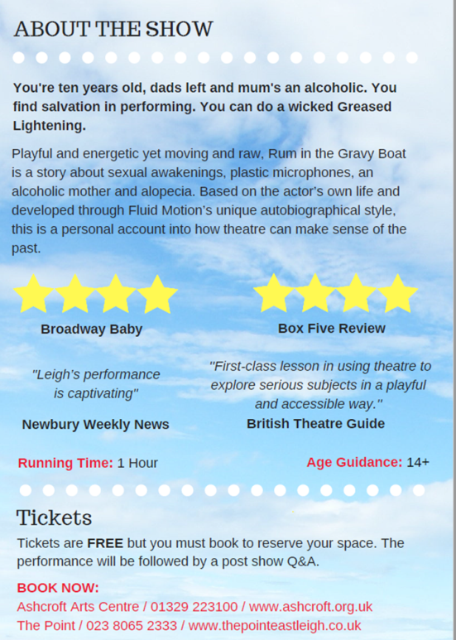
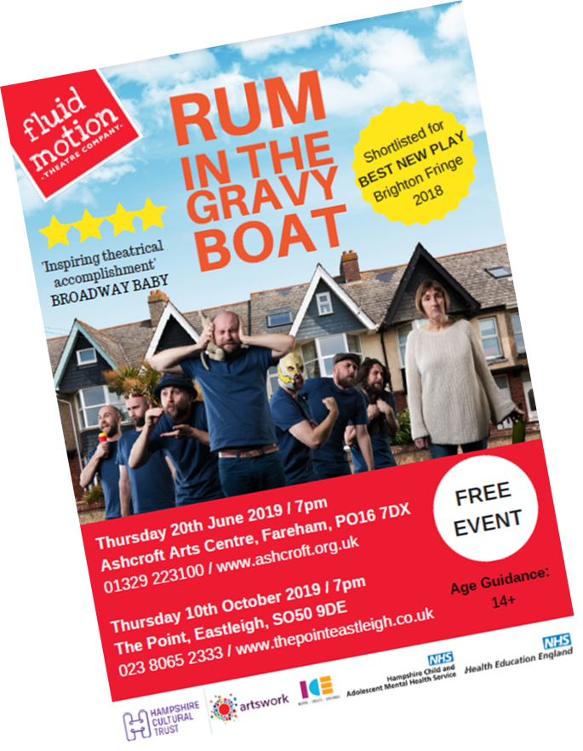

ABC (Advanced Better Care) Training
Child and Adolescent Mental Health Services (CAMHS) in Hampshire organised four one day training events called ABC Training (Advanced Better Care) throughout 2019 across Hampshire. This event is one of four that are included within the 2019 Hear Me Campaign; a yearlong campaign about Children in Care.
Aims of ABC Training
- To engage professionals and families in understanding the needs and difficulties young people in care face and increase their confidence and knowledge managing potential issues or concerns
- To develop practical and specific skills to support young people in care who may experience mental health difficulties
- To provide information in a way that is helpful, engaging and non-threatening.
- To present information that will destigmatise mental illness and other related issues
- Raise awareness of potential issues and where to seek help, advice and support.

The event hosted a variety of workshops that focused on issues, relevant for many professionals (including foster and adoptive parents) who work, support or care for a young person in care. The specialist workshops were focussed on gaining skills and knowledge to manage and understand, and where to seek support if required. Workshop topics included; Managing challenging behaviour, Managing anxiety (for primary and secondary school aged young people), Supporting a young person in crisis, Trauma and CARE (Coping and Resilience Education) Skills. These workshops were facilitated by clinicians and practitioners from Hampshire CAMHS and Hampshire Primary Behaviour Service.
Andover Event; 23rd May 2019
Data was collated by asking attendees to complete a subjective feedback form; 120 people booked to attend the event, 27 people attended and 22 completed feedback forms were returned.
Number of Attendees
The table below illustrates in what capacity(s) individuals attended the ABC. event.

 | Parent/ Carer | Education Professional | Social Care Professional | Health Care Professional | Other
Total |  | 11 | 7 | 3 | 1

Where people heard about the event
 | Direct from CAMHS | Online CAMHS Social Media | ABC Promotional Material | Word of Mouth/ Disseminated
Total | 7 | 3 | 1 | 11

The graph below illustrates whether the event helped to increase attendee’s knowledge and awareness of how to support and work with a young person in care.
Of the 22 attendees that responded, 96% (n=21) felt their knowledge and understanding had increased ‘very much’ or ‘a lot’.

The graph below illustrates whether attendees felt the event taught practical skills and strategies that could be used directly with young people in care.

Of the 22 attendees that responded, 100% (n=22) reported they had learnt skills and strategies ‘very much’ or ‘a lot’.

The graph below illustrates whether attendees felt the event provided networking opportunities and increased awareness of organisations available to support wither professionals/ carers or young people in care.

Of the 22 attendees that responded, 45% (n= 10) reported the event provided opportunities for networking ‘very much’ or ‘a lot’ and 50% (n=11) reported the event provided opportunities for networking ‘a little.

The graph below illustrates whether attendees felt the venue was comfortable and appropriate for the event.

Of the 22 attendees that responded, 82% (n=18) felt the venue was comfortable and appropriate ‘very much’ or ‘a lot’.

The table below summarises what attendees found most useful about the event.

Theme | Number of responses
Information sharing and advice | 8
Practical Strategies | 13
Useful Resources | 9
Networking with multiagency professionals | 1

The table below summarises improvements and recommendations that attendees provided:

Theme | Number of responses
Provide a lunch break and refreshments | 8
Smaller venue due to low numbers | 1
Longer breaks between workshops | 1
Some repetition between workshops | 1
Longer workshops | 2

The table below summarises general feedback from attendees:

Theme | Number of responses
Thanks and appreciation for the day | 7
Useful and informative event | 5

Specific Workshop Evaluations

Anxiety management
Aims of the workshop:
- An introduction to what anxiety is
- Signs and symptoms of anxiety
- Strategies to manage anxiety
- Resources

Supporting a young person in crisis
Aims of the workshop:
- Signs and symptoms demonstrated by young people when in crisis
- Tips of how to communicate with and support a young person who discloses they are in crisis/ struggling or if you have concerns a young person may not be coping
- Where to access further support/advice
CARE (Coping and Resilience Education) Skills
Aims of the workshop:
- Helping young people identify and express what is going on for them (and their emotions)
- Top tips on what to do (and not to do)
- Practical skills and resources

Managing challenging behaviour
Aims of the workshop
- To help with improving understanding of your child and their needs
- To help develop a better relationship with your child
- To learn practical and effective strategies you can try

Trauma
Aims of the workshop:
- Understanding what trauma is and how it impacts on young people
- Signs and symptoms that a young person may be experiencing trauma or impacted by trauma
- How to support a young person with trauma

Gosport Event; 14th June 2019
Number of Attendees
The table below illustrates in what capacity(s) individuals attended the ABC. event.
 | Parent/ Carer | Education Professional | Social Care Professional | Health Care Professional | Other
Total | 5 | 3 | 5 | 5 | 1

Where people heard about the event
 | Direct from CAMHS | Online CAMHS Social Media | ABC Promotional Material | Word of Mouth/ Disseminated
Total | 12 | 3 | 1 | 3

The graph below illustrates whether the event helped to increase attendee’s knowledge and awareness of how to support and work with a young person in care.

Of the 19 attendees that responded, 58% (n=11) felt their knowledge and understanding had increased ‘very much’ or ‘a lot’.

The graph below illustrates whether attendees felt the event taught practical skills and strategies that could be used directly with young people in care.

Of the 19 attendees that responded, 47% (n=9) reported they had learnt skills and strategies ‘very much’ or ‘a lot’.

The graph below illustrates whether attendees felt the event provided networking opportunities and increased awareness of organisations available to support wither professionals/ carers or young people in care.

Of the 19 attendees that responded, 30% (n= 6) reported the event provided opportunities for networking ‘very much’ or ‘a lot’ and 35% (n=7) reported the event provided opportunities for networking ‘a little.

The graph below illustrates whether attendees felt the venue was comfortable and appropriate for the event.
Of the 22 attendees that responded, 50% (n=10) felt the venue was comfortable and appropriate ‘very much’ or ‘a lot’.

The table below summarises what attendees found most useful about the event.

Theme | Number of responses
Information sharing and advice | 7
Practical Strategies | 6
Useful Resources | 1
Opportunity for 1:1 support | 2

The table below summarises improvements and recommendations that attendees provided:

Theme | Number of responses
Provide a lunch break and refreshments | 1
Timing of workshops- some ran over | 2
Sitting in a circle rather than theatre style & more interaction | 3
Some repetition between workshops | 2
Better advertising of events | 2
Longer workshops | 2

The table below summarises general feedback from attendees:

Theme | Number of responses
Thanks and appreciation for the day | 6
Useful and informative event | 2

Specific Workshop Evaluations
Anxiety management

Supporting a young person in crisis

CARE (Coping and Resilience Education) Skills

Managing challenging behaviour

Trauma

Eastleigh Event; 22nd October 2019
Number of Attendees
The table below illustrates in what capacity(s) individuals attended the ABC. event.
 | Parent/ Carer | Education Professional | Social Care Professional | Health Care Professional | Other
Total | 12 | 16 | 16 | 10 | 4

Where people heard about the event
 | Direct from CAMHS | Online CAMHS Social Media | ABC Promotional Material | Word of Mouth/ Disseminated
Total | 24 | 3 | 6 | 26

The graph below illustrates whether the event helped to increase attendee’s knowledge and awareness of how to support and work with a young person in care.

Of the 59 attendees that responded, 83% (n=49) felt their knowledge and understanding had increased ‘very much’ or ‘a lot’.

The graph below illustrates whether attendees felt the event taught practical skills and strategies that could be used directly with young people in care.

Of the 59 attendees that responded, 88% (n=52) reported they had learnt skills and strategies ‘very much’ or ‘a lot’.

The graph below illustrates whether attendees felt the event provided networking opportunities and increased awareness of organisations available to support wither professionals/ carers or young people in care.
Of the 59 attendees that responded, 61% (n= 36) reported the event provided opportunities for networking ‘very much’ or ‘a lot’ and 14% (n=8) reported the event provided opportunities for networking ‘a little.

The graph below illustrates whether attendees felt the venue was comfortable and appropriate for the event.
Of the 59 attendees that responded, 78% (n=46) felt the venue was comfortable and appropriate ‘very much’ or ‘a lot’.

The table below summarises what attendees found most useful about the event.
Theme | Number of responses
Information sharing and advice | 19
Practical Strategies and resources | 29
Gaining/ refreshing knowledge about children in care and adjustments needed | 6
Opportunity for 1:1 support and time with facilitators | 1
Everything was useful | 7

The table below summarises improvements and recommendations that attendees provided:
Theme | Number of responses
Provide a lunch break and refreshments | 9
Timing of workshops- some ran over, need longer between workshops | 6
Not having all the workshops on one day | 1
Some repetition between workshops | 1
Improved IT facilities | 1
Longer workshops | 4
More interaction and participation from attendees | 1

The table below summarises general feedback from attendees:
Theme | Number of responses
Thanks and appreciation for the day | 14
Useful and informative event, high quality information and expertise available | 7
Would like to disseminate this to others/ make it compulsory for all foster carers and professionals/ desire for more training days | 5
Passionate and knowledgeable presenters | 9
Well organised event | 3

Specific Workshop Evaluations
Anxiety management

Supporting a young person in crisis

CARE (Coping and Resilience Education) Skills

Managing challenging behaviour

Trauma

New Forest; 6th November 2019
Number of Attendees
The table below illustrates in what capacity(s) individuals attended the ABC. event.
 | Parent/ Carer | Education Professional | Social Care Professional | Health Care Professional | Other
Total | 10 | 8 | 7 | 2 | 4

Where people heard about the event
 | Direct from CAMHS | Online CAMHS Social Media | ABC Promotional Material | Word of Mouth/ Disseminated
Total | 14 | 3 | 5 | 10

The graph below illustrates whether the event helped to increase attendee’s knowledge and awareness of how to support and work with a young person in care.
Of the 32 attendees that responded, 72% (n=23) felt their knowledge and understanding had increased ‘very much’ or ‘a lot’.

The graph below illustrates whether attendees felt the event taught practical skills and strategies that could be used directly with young people in care.
Of the 32 attendees that responded, 82% (n=26) reported they had learnt skills and strategies ‘very much’ or ‘a lot’.

The graph below illustrates whether attendees felt the event provided networking opportunities and increased awareness of organisations available to support wither professionals/ carers or young people in care.
Of the 32 attendees that responded, 38% (n= 12) reported the event provided opportunities for networking ‘very much’ or ‘a lot’ and 44% (n=14) reported the event provided opportunities for networking ‘a little.

The graph below illustrates whether attendees felt the venue was comfortable and appropriate for the event.
Of the 32 attendees that responded, 38% (n=12) felt the venue was comfortable and appropriate ‘very much’ or ‘a lot’.

The table below summarises what attendees found most useful about the event.
Theme | Number of responses
Information sharing and advice | 4
Practical Strategies and resources | 18
Everything was useful | 3

The table below summarises improvements and recommendations that attendees provided:
Theme | Number of responses
Provide a lunch break and refreshments | 4
Timing of workshops- some ran over, need longer between workshops | 3
Some repetition between workshops | 1
Improved IT facilities | 3
Better (cheaper) car parking | 2

The table below summarises general feedback from attendees:
Theme | Number of responses
Thanks and appreciation for the day | 3
Useful and informative event, high quality information and expertise available | 5
Request for more training days | 3
Passionate and knowledgeable presenters | 4

Specific Workshop Evaluations
Anxiety management

Supporting a young person in crisis

CARE (Coping and Resilience Education) Skills

Managing challenging behaviour

Trauma

Comments and feedback:

Good it was so targeted for children in care
Professional facilitators with a lot of experience
Would love to have this delivered to our whole staff team!
Help refresh my knowledge and skills
Very informative; can’t believe so much was covered in one day
Good for refreshing knowledge and learning new skills

This should be a compulsory course for all foster carers

Everything linked really well
I have so much information and resources to go back to my team with
It was good to learn CAMHS messages are consistent with the ones we promote
Thank you. The day was invaluable for myself and the young people I work with

Passionate excellent speakers
I’ve learnt some great new ideas for working with young people
It was great facilitators were available throughout the day for consultation and advice

Young people focus Groups
Four focus groups were held with children in care across Hampshire. 84 young people aged between 8-14years old participated. Their feedback formed part of the Hear Me Exhibition and was displayed on colourful posters, pictured below. An anonymous online survey was also conducted to gather the views of those who have lived in care; 26 people responded.

How can adults take young people seriously?
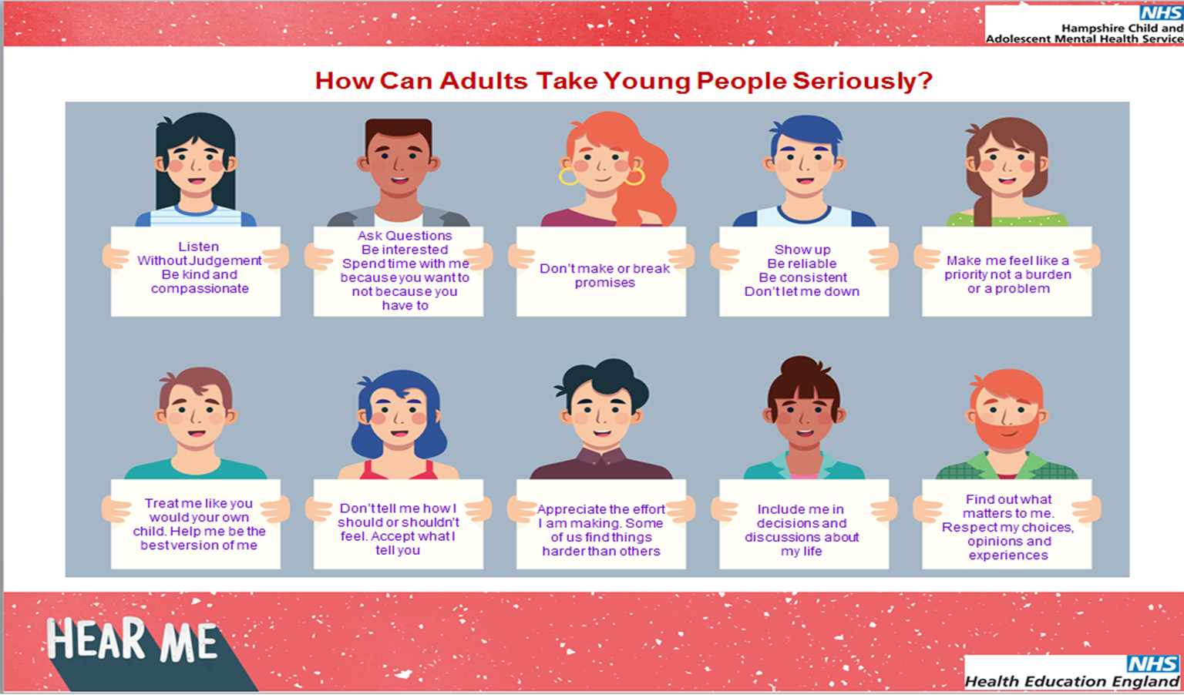

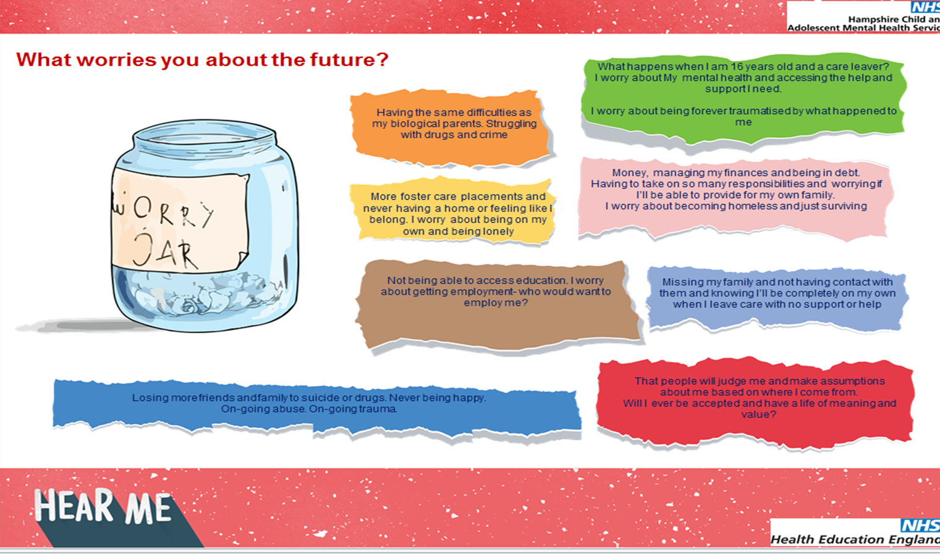
What worries you about the future?

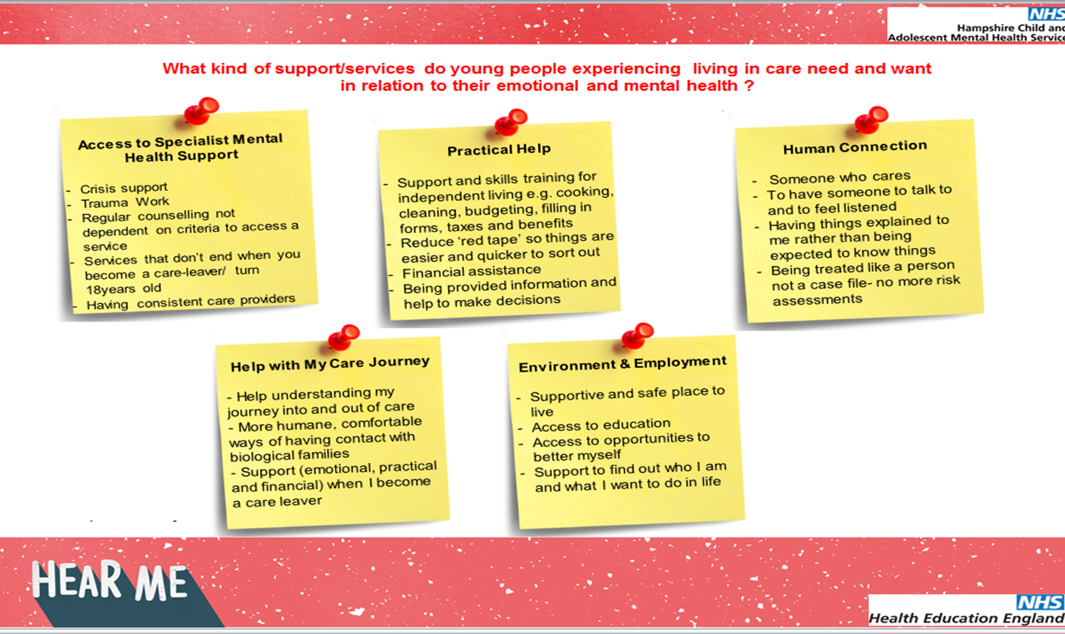
What kind of support/services do young people experiencing living in care need and want in relation to their emotional and mental health ?
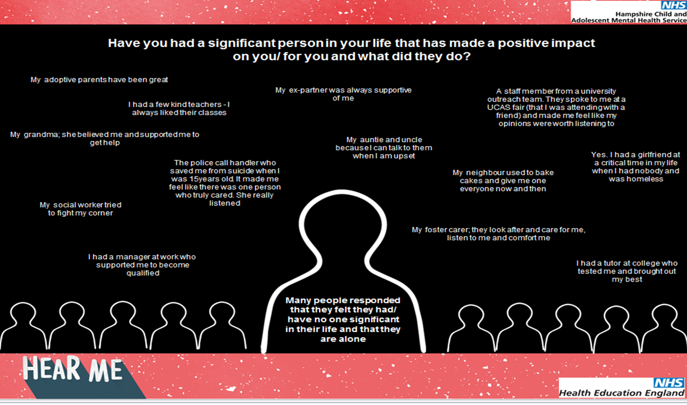
Have you had a significant person in your life that has made a positive impact on you/ for you and what did they do?
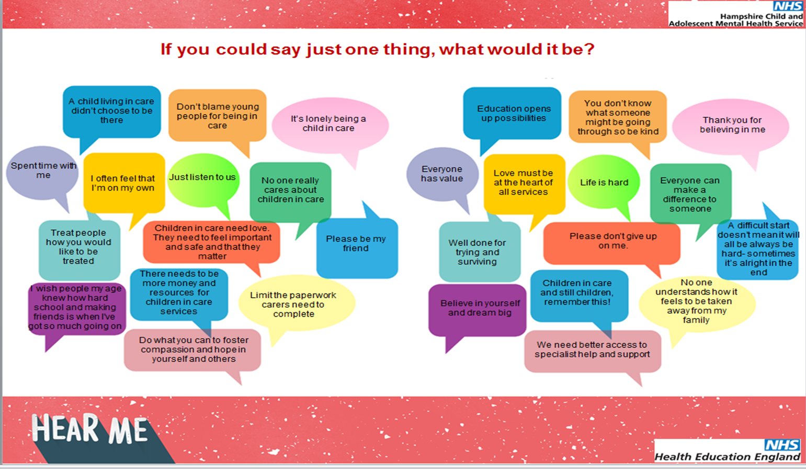
If you could say just one thing, what would it be?
Foster Carer Network Conference
Hampshire CAMHS were invited to present at the annual Foster Carer Network Conference in September 2019 as well as have an information stand. This was an opportunity to share with parents/ carers and professionals information about the Hear Me Campaign as well as information about the Hampshire CAMHS Service.
Feedback from some of the attendees included;
- Concern that Hampshire CAMHS are not able to provide consistent or continuous care for young people that experience multiple placements and move around Hampshire. In these instances, care is transferred to the new local team which can be hugely disruptive and distressing for the young person and their network
- There is insufficient immediate access to support for foster and adoptive parents when young people are in crisis. Similarly, that there is insufficient provision for support such as debriefs and reflective practice following critical, serious, near miss or generally distressing incidents. Several foster and adoptive parents reflected that the lack of support and resources available to them can lead to placement breakdown which can contribute to further trauma and distress experienced by young people and their carers.
- Concern that young people living in care with complex needs are not being accepted for initial assessment by Hampshire CAMHS and there is limited access to guidance or rationale for understanding what the eligibility criteria are.
- Concern that when young people are not accepted by CAMHS that there are little to no alternative provisions for young people in care with emotional and psychological difficulties.

Hear Me Exhibition and Just One Thing- The Suitcase Installation
A free, openly accessible temporary pop-up exhibition was held within a vacant space within Festival Place Shopping Centre, Basingstoke, Hampshire from November 22nd 2019 until January 8th 2020. The exhibition featured information about the Hear Me Campaign, art work produced by young people living in care, the public art installation, Just One Thing; The Suitcase. This emotionally evocative art installation depicted through sculpture the responses of those who have had experience of living in care who were asked the question
“What was the one possession that you remember taking with you the first time that you went into care?’
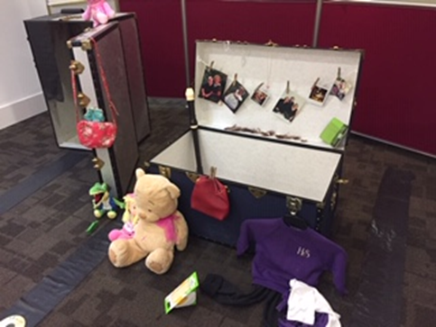

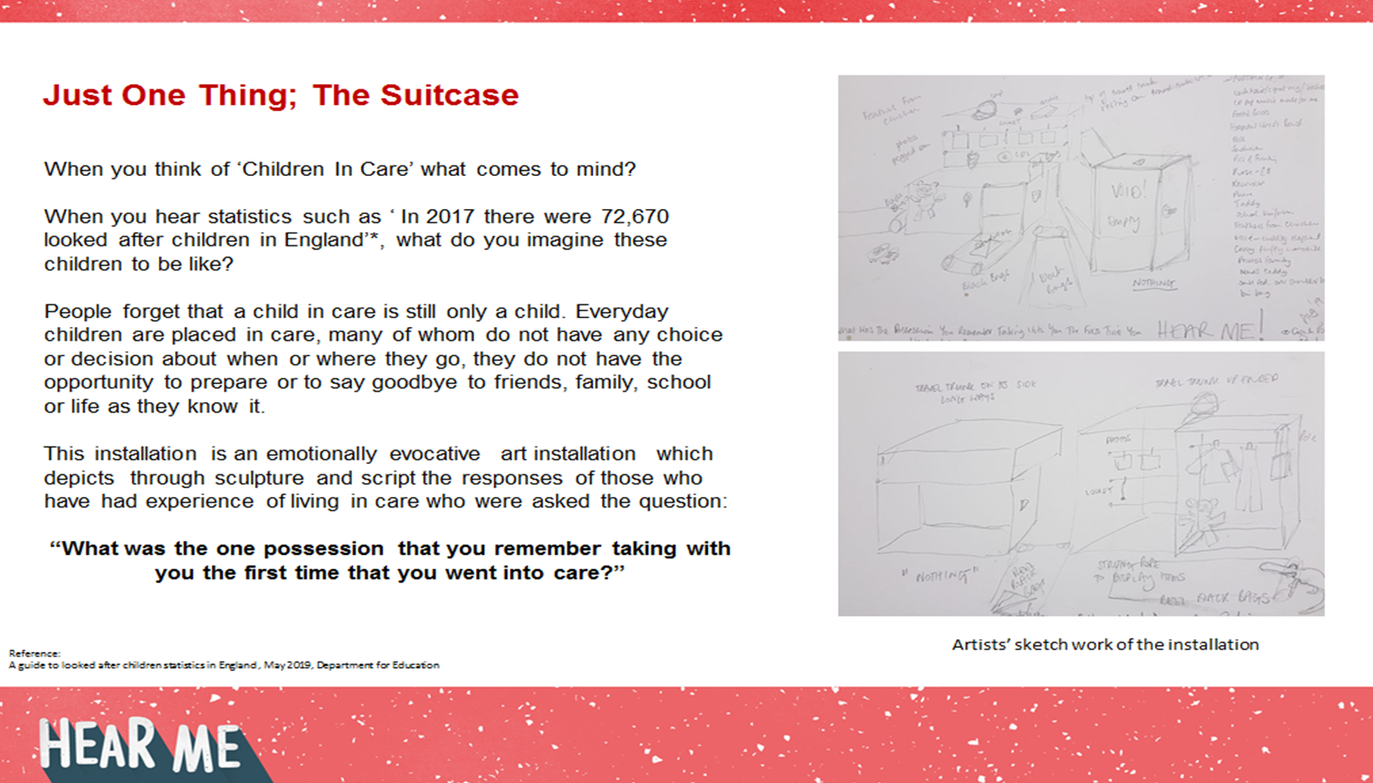

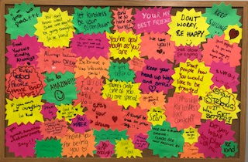
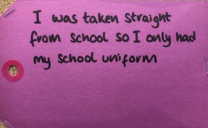
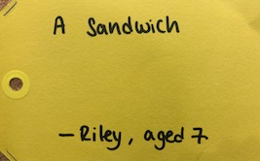
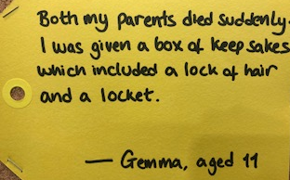
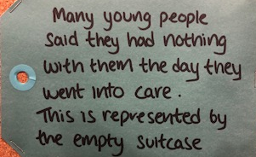

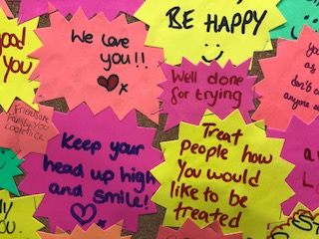
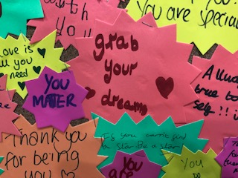

As part of the exhibition, people attending were encouraged to leave their feedback and comments on specially designed postcards which were displayed as an interactive feature of the exhibition as well as forming part of the exhibition evaluation.
A table of resources was also freely available for people to take; information about mental health, the Hampshire CAMHS service and self-help resources (e.g., two versions of an A-Z of coping strategy leaflet, Hampshire CAMHS website leaflet, eating disorder awareness Stickers, coping strategy keyrings, SAFE- Suicide Awareness For Everyone Cards, PACE- Parent/ carer and professional information leaflets about forthcoming events, Hampshire CAMHS information and business cards).

Some of the feedback that was left on comment cards:

"Thanks for giving young people a chance to share their experiences with us. Very emotive"
"The suitcase is incredibly emotional"
"A fantastic platform to give young people a voice when they don’t feel like they have one. Heart-breaking that their lives are turned upside down. Thank you for sharing and caring"
"Time has come to let the voices be heard. It is very inspirational and motivational. Best thing to do for the younger generation is to be heard"
"Deeply moved to tears by the awareness of so many children in care with eye opening and powerful stories to tell. This exhibition evokes compassion, empathy and love for the children and their perseverance, grit and openness. What action can we take to help?"
"The suitcase display was incredibly moving and shows the reality of these children's experiences. Truly eye opening, thank you"
"Amazing exhibition. Mental health is not spoken about enough. Please share this as an example of good practice with other NHS regions"
"The suitcase exhibition is heart-breaking and so moving"
"I love the suitcase display- huge sentiment behind seemingly inanimate objects"
"As a children's social worker, it is so goof to see the voices of children shared like this for the public to see. Very thought provoking"
"It makes me realise how fortunate I am to have a family"
"Very useful in bringing out often 'hidden' aspects and the voices of young people in care"
"So grateful this exists. Everyone in the country deserves to see it"

Digital Information
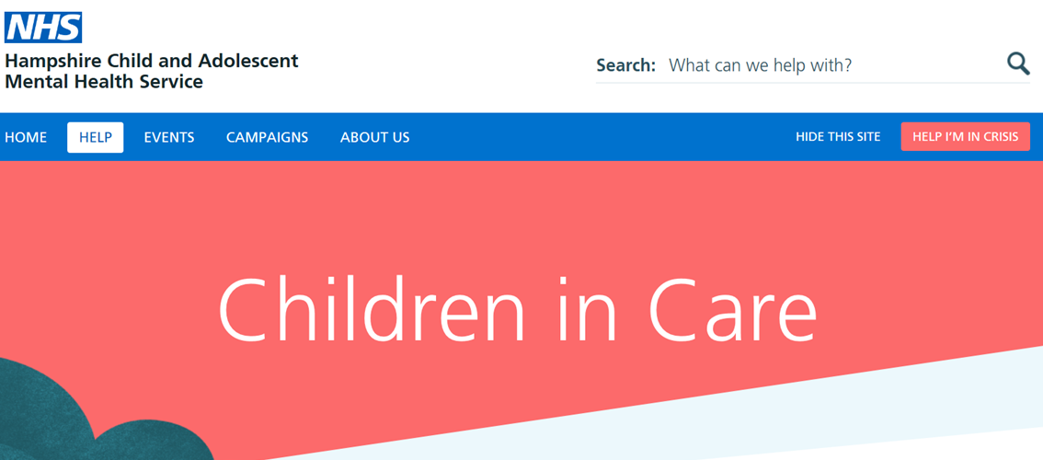
On the Hampshire CAMHS website (www.hampshirecamhs.nhs.uk) a section was added under the Help Section for young people, parents and carers and professionals. This contains information and signposting to other resources which are useful for young people living in care as well as parents/ carers and professionals.

Summary
The aims and objects of the HEAR ME Campaign 2019 were successfully met. There are plans to continue working with our stakeholders and other agencies to provide on-going care and innovative projects for children in care, parents and carers and professionals.
With thanks to Health Education England for their financial contribution to this campaign.

December 2019.

