Cognative Stimulation Therpy:
Living Well with Dementia , Food Tasting and Nutrition Education Sesssions

5 weeks of tasting new and exciting foods and learning how to prepare them and what health benefits they have

Week 1
Avocado
Sweet Potato
Mango

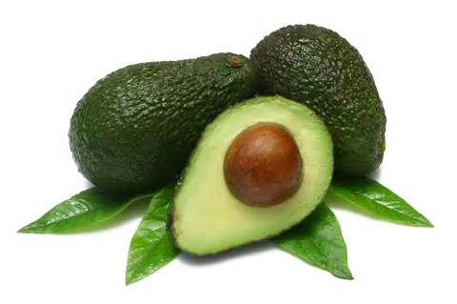
This is a Avocado, this is a Fruit, but can be used as Vegetable

What are the health benefits of Avocado?
Avocados do not contain any cholesterol or sodium, and are low in saturated fat.Avocados are packed full of all essential nutrients. In 100gs of avocado there are large amounts of Vitamin K, Folate, Vitamin C. Potassium, Vitamin B5, Vitamin B6, Vitamin E, Then it contains small amounts of Magnesium, Manganese, Copper, Iron, Zinc, Phosphorous, Vitamin A, B1 (Thiamine), B2 (Riboflavin) and B3 (Niacin).
What do I do with it?
You need to cut the avocado in half and remove the stone, scoop out the light green flesh and throw away the skin and stone (you can’t eat these bits.) Then you can eat the avocado with a pinch of salt and pepper, mash / squash it with a fork so it combines to a spreadable consistency. You can spread it on cracker, toast or bread to make or add to a sandwich, or you can cut it into cubes and eat with a salad or meal of your choosing.

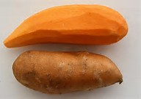
This is a Sweet potato is a Vegetable

What are the health benefits of Sweet Potatoes?
Sweet Potatoes are rich in Vitamin A, Vitamin C and Potassium. The recommended daily amount of vitamin A can be achieved with only 100 grams of sweet It is rich in an antioxidant called beta-carotene, which is very effective at raising blood levels of vitamin A. potatoes. Vitamin C is an antioxidant, which may decrease the duration of common colds and improve skin health. Potassium is important for blood pressure control; this mineral may decrease the risk of heart disease
What do I do with it?
You can use this potato like an ordinary potato; Make a jacket potato by pricking it several time with a fork and microwave or oven until soft all the way through. You can peel and cut it to make mash potato as you would with normal potatoes. You can make chips with them, you can leave the skin on and then cut into chips and then use your preferred method of making chips.

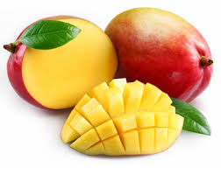
This is a Mango, this is a fruit

What are the Health benefits of Mangos?
Mangos contain over 20 vitamins and minerals, such as Vitamin K, Fibre, Potassium, Calcium and Vitamin C. the vast combination of these vitamins and minerals can promote healthy hearts, improve digestion and bone health, and can help maintain healthy skin and hair.
What do I do with it?
You need to remove the skin and stone of the mango. You can do this by peeling the skin off or by cutting sections off. You can’t eat the skin or stone of this fruit. Removing the skin and stone can be a little tricky so be careful with the sharp knife. Once you have the yellow flesh, enjoy the mango as you would any other fruit, either on its own or part of a fruit salad.

Week 2:
Pineapple,
Beetroot,
Eggs

This is a Pineapple, it is a fruit.

What are the Health benefits of Pineapples?
Pineapples have good quantities of Vitamin A, vitamin c, Fibre and Potassium. The Fibre, Potassium and Vitamin C in Pineapple help to maintain a healthy heart and reduce inflammation and swelling.
What do I do with it?
You need to remove the skin of the Pineapple. You can do this by cutting off head and bottom of the Pineapple and then cutting off the skin. You can’t eat the skin and stone, this can be a little tricky so be careful with the sharp knife. Once you have the yellow flesh, enjoy the Pineapple as you would any other fruit, either on its own or part of a fruit salad.

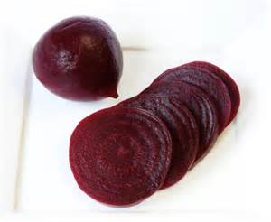
This is Beetroot, it is a vegetable

What are the Health benefits of Beetroot?
Beetroot contains potassium, magnesium, iron, vitamins A, B6 and Vitamin C, folic acid, carbohydrates, protein, antioxidants and fibre. The nitrates in beetroot help to widen blood vessels in the body which can improve blood flow and lower blood pressure. Drinking beetroot juice increases blood flow to the brain in older people, which may be able to fight the progression of dementia, a 2010 study suggested.
What do I do with it?
You can buy beetroot already prepared from the supermarket as a whole bulb or as cut up. This available as fresh or in a jar pickled. If you buy Beetroot raw skill in its skin you need to remove the skin then boil or pickle it before you can it. You can use it in a salad, on a sandwich or on its own as snack. Be care though … you may get purple hands for a few days! The colour of the Beetroot can stain the surface it touches so try not to drop it or handle it too much.

These are Eggs, this is a dairy product.
What are the Health benefits of Eggs?
Eggs are a really good source of protein and contain a good amount of healthy cholesterol. They are packed full of Vitamins and minerals that help to aid healthy bodily functions. Such as Zinc, Iron and B6 and B12 vitamins A, D, E and K
What do I do with it?
You can make Boiled egg by placing the egg in a pan and covering with cold water. You then boil them for 12 minutes if you want soft, 15 minutes for a medium boiled and 17-18 for hard boiled.
You can make Scrambled egg by removing the egg from its shell before, putting the eggs into a bowl and then whisking until thoroughly mixed. You then can use the microwave to cook the eggs; usually this is between 3-5 minutes depending on the setting of your microwave. Or you can use a pan, in which case you would need to put a small amount of butter in the pan, turn on the pan ring and begin to melt over the heat. Then add you eggs and gently continue to fold the eggs in the pan until they are cooked.

Week 3:
Dates,
Pumpkin,
Sugar Snap Peas

These is a Date, This is a Dried Fruit

What are the Health benefits of Dates?
Dates are a good source of fibre; they contain a great deal of iron, calcium, potassium and vitamin A.
What can I do with this?
Some dates may have a stone that needs to be removed; you can’t eat the stone, but can eat the rest of the date. You can buy the dates already pitted.
You can use this fruit as a snack or as part of a dessert. However be careful not to eat too many as they can have a laxative effect in large quantities.

This is a Pumpkin, This is a Vegetable

What are the Health benefits of Pumpkin?
Pumpkins are rich in Vitamin C which can help the Immune system. A cup of cooked, mashed pumpkin contains more than 200 percent of your recommended daily intake of vitamin A, which aids vision, particularly in dim light. Pumpkins are also rich in carotenoids, the compounds that give the gourd their bright orange color, including beta-carotene, which the body converts into a form of vitamin A for additional peeper protection.
What can I do with this?
You can’t eat the skin of this vegetable. You can make soup with this vegetable, you can roast it or you can mash it. Use it as you would a potato.

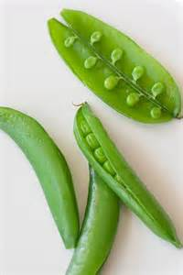
These are Sugar Snap Peas,This is a Vegetables

What are the Health benefits of Sugar Snap Peas?
This vegetable is a good source of vitamin A , K , full of iron and one cup of them has up to 5gs of fibre. They are low on the glycaemic index; this means they help won’t spike your blood sugar.

What can I do with this?
You can eat all of this vegetable; you just need to wash them before use.
You can use sugar snap peas as you would other green vegetables. You can steam them or sauté them in a little oil and seasoning for around 3-5 minutes.
You can add them as part of a meal or use them as snack.

Week 4:
Coconut water
CottageCheese
DarkChocolate

This is Coconut Water; it is a natural fruit juice drink.

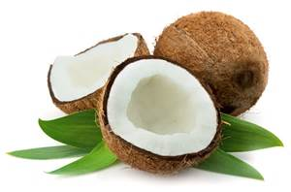

What are the benefits of Coconut Water?
Coconut water is rich in Nutrients and contains five essential electrolytes: calcium, magnesium, phosphorous, potassium and sodium. Coconut water serves as an excellent drink replacement as it contains 294 mg of potassium and 5 mg of natural sugar per glass, unlike other processed drinks that only contains five times the amount of processed sugar. In addition, the sodium count is only 25 mg. The balance of electrolytes can aid in controlling blood pressure.
What do I do with this?
You can use this as a refreshing drink alternative to water or fruit juice.

This is Cottage Cheese, it is a Diary Product.
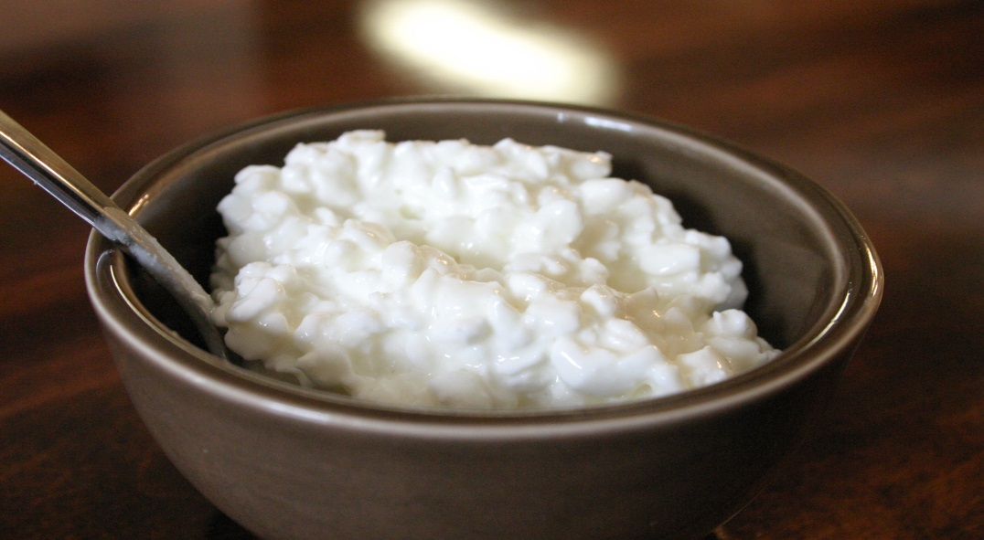

What can I do with this?
You can add it to salads as a side serving, you can put it with a jacket potato (or even a sweet jacket potato), you could add it as a filling for a sandwich, or you can eat it as a snack with a little salt and pepper on its own or on a cracker.

What is the benefit of Cottage Cheese?
Cottage Cheese has a high protein, which helps to protect and repair muscles, and keeps you fuller for longer as protein is broken down slowly. Cottage cheese has a good amount of calcium which in bone and teeth protection and protecting and maintain adequate cardiovascular functioning.

This is Dark Chocolate, it is a Sweet Treat

What are the benefits of Dark Chocolate?
The powerful antioxidants in chocolate are Flavanoids, which also include resveratrol. This can help control insulin levels and reduce inflammation and increases the antioxidant levels in the blood, protecting cells from damage. This also protects DNA from cancer causing damage. In addition, it helps prevent damage to the heart and blood vessels, also helping to control inflammation. It may also decrease platelet activity, which contributes to heart health
What do I do with this?
You eat it however you like

Week 5:
Spinach
Kiwi
Bulgar Wheat

These are Spinach, this is a are a Vegetable .
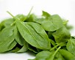
What are the benefits of Spinach?
Spinach is a readily available leafy green and has a huge amount of Nutrients! Just to name a few, spinach contains: Vitamin K, Vitamin A, Magnesium, Foliate, Manganese, Iron, Calcium, Vitamin C, Vitamin B2, Potassium, and Vitamin B6. It’s a very good source of Protein, Vitamin E, Zinc, Dietary Fibre, and Copper. Plus, it’s a good source of Omega-3 fatty acids! It is rich in Flavonoids and contains a great deal of anti-inflammatory properties.
What can I do with this?
Spinach is a versatile food. It can be eaten raw in a salad; it can be cooked to be wilted down. If boiling, use the least amount of water possible for the shortest time. You can add this fabulous nutrient to any meal as you would any other green vegetable… its great wilted down and mixed with a little cream cheese!

This is a Kiwi, it is a Fruit.
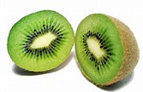
What are the benefits of Kiwi?
Kiwis have a high amount of Fibre and are a good source of slow digestable carbohydrates. They are low in fat and packed full of essential vitamins and minerals. Kiwifruit are exceptionally high in vitamins C, E, K, foliate, carotenoids, potassium, fibre, and phytochemicals acting in synergy to achieve multiple health benefits”
What can I do with this?
You can’t eat the skin of a Kiwi. The easiest way to eat a kiwi is by cutting it in half and then using a spoon to scoop out the insides. You can then either put it with a fruit salad or as a solo snack straight from the spoon!

This is Bulgar Wheat, it is a Grain.
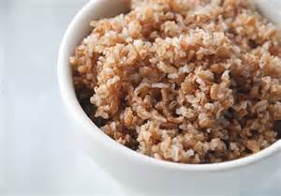
What are the benefits of eating Bulgar wheat?
Bulgar Wheat is richer in nutrients and vitamins than refined, processed wheat’s ; Bulgur wheat has a high proportion of Insoluble fibre which helps food move more rapidly through the intestines, helps your body use insulin more effectively and lowers triglycerides, or unhealthy fats found in the blood. Bulgar wheat has a good amount of magnesium which is essential for normal brain and nerve function. One cup of cooked bulgur wheat supplies almost 15% of you recommended daily amount of magnesium.
What can I do with this?
Use Bulgar Wheat as you would rice. Decide on how much Bulgar wheat you would like, then use that double the amount of water for cooking. Bring the water to boil in a pan. Boil for around 10-15 minutes until soft. This is rice like grain so remember it will puff up once cooked... Be careful with your portion. You can add Bulgar Wheat to any of the dishes you would usual have with rice as a pleasant alternative. A little seasoning such as a pinch of curry powder and herbs adds a lot good flavour!

I hope you have found these sessions interesting and have enjoyed the experience of trying new foods.
Thank you for you continued participation, patience’s and contributions in group discussion.

Thank you
Simone Taylor
(Student Nurse)

