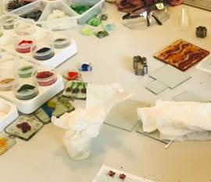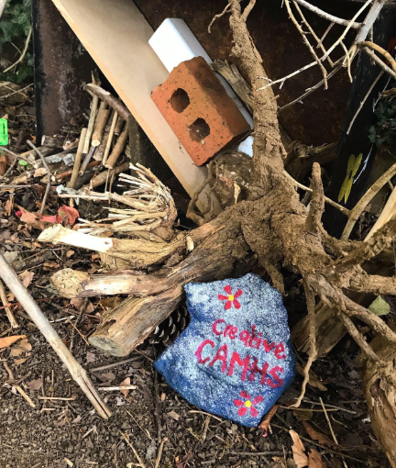



**PEER SUPPORT:**

We have successful completed a pilot project to introduce peer support into CAMHS. Peer Support Workers are now a permanent part of Lincolnshire CAMHS workforce.

Lincolnshire CAMHS Continuous Quality Improvement 2019



**ANIMAL ASSISTED THERAPY:**

We have successfully introduced therapy dogs across CAMHS, there are now seven therapy dogs working alongside the teams.



**CREATIVE CAMHS:**

A group developed by peer support and clinicians in collaboration with young people to provide a recovery-focused group and environment; moving away from symptom-reduction to skill development, social interaction, promoting coping skills and providing opportunity for meaningful activity.



**LGBTQ+ Group:**

We are currently planning a new group, this will aim to engage young people identifying as LGBTQ+ in projects around raise awareness

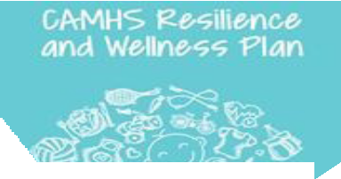

**RESILIENCE & WELLNESS PLAN:**

We are currently developing a wellness plan, that is a therapeutic plan to help young people look after their emotional wellbeing and feel more confident about their future.