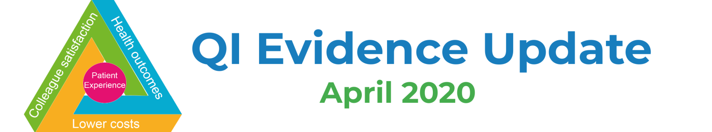

Our top 3 reads
- How to create real, lasting change after COVID-19 article and tool (The RSA, April 2020)
- Online Engagement: A guide to creating and running virtual meetings and events (NCCPE, April 2020)
- ELFT Quality Improvement Department ‘tests’ virtual Pocket QI training – Cycle 1 (March 2020) and Cycle 2 (May 2020)

Improvement
- Choices for the “New Normal” by Don Berwick (JAMA, May 2020)
- Quality improvement in the time of COVID-19 – a change strategy well suited to pandemic response (Canadian Association of Emergency Physicians, May 2020)
- Healthcare improvement in the time of COVID (Q Community, April 2020)
- ‘Weeknotes’ from Q community – what’s happening across improvement? – Week 1 and Week 2 (Q Community, May 2020)
- How QI teams are responding to COVID-19 (BLOG) (LifeQI, April 2020)
- PDSA during the COVID-19 Pandemic (VIDEO) (Advancing Quality Alliance, April 2020)
- Learning the lessons: techniques to capture and share the learning (VIDEO) (HEE, April 2020)
- The Academy of Fabulous Stuff – Covid Resources & Innovations (Fab, Ongoing)
- The Academy of Fabulous Stuff #NoGoingBack (Fab, Ongoing)

Wellbeing
- To Take Care of Others, Start by Taking Care of Yourself (Harvard Business Review, April 2020)
- Working from Home and Wellbeing – Collection of Resources (HEE, April 2020)
- The psychological needs of healthcare staff as a result of the Coronavirus pandemic (British Psychological Society, March 2020)

Adjusting to remote working
- Stop Zoning Out in Zoom Meetings (Harvard Business Review, May 2020)
- Leading virtual meetings – top tips (The Kings Fund, April 2020)
- Leader's remote working handbook (PA Consulting, April 2020)
- Break Up Your Big Virtual Meetings (Harvard Business Review, April 2020)
- How to Combat Zoom Fatigue (Harvard Business Review, April 2020)
- How to Make Your (Now Virtual) Event Shine (MIT Sloan Management Review, April 2020)

COVID-19
- Covid-19 Guidance and Resources (The IHI, April 2020)
- Coronavirus guidance for clinicians and NHS managers (NHSE/I)
- Finding the evidence: Coronavirus (Public Health England, March 2020)
- NICE rapid guidelines and evidence reviews (NICE, March 2020)
- Coronavirus (COVID-19) - Cochrane resources and news (Cochrane, March 2020)
- The Royal College of Emergency Medicine Covid-19 Resources (RCEM, March 2020)
- HFMATalk Covid-19 Podcasts (HFMA, Ongoing)
- Critical care services in the English NHS (BRIEFING) (The Kings Fund, April 2020)

Technology
- University Hospitals Birmingham starts AI melanoma pilot (Health Tech Newspaper, May 2020)
- Video messaging service supports Tunbridge Wells Hospital’s Neonatal Unit (Health Tech Newspaper, May 2020)
- HTN Trends Series: Health tech leaders highlight challenges and responses during COVID-19 (Health Tech Newspaper, April 2020)
- COVID-19 and Early Intervention: Evidence, challenges and risks relating to virtual and digital delivery (Early Intervention Foundation, April 2020)
- Virtual health care in the era of COVID (The Lancet, April 2020)
- Clinically-proven gamification app teaches positive inhaler technique; crucial for managing asthma (Health Tech Digital, April 2020)
- NHS Wales to implement IBM Watson COVID-19 virtual assistant (Health Tech Newspaper, April 2020)
- The Keys to Effective Telemedicine for Older Adults (BLOG) (The IHI, April 2020)

Events & Training
- TEDx NHS Talks from 2019, 2018, 2017 and 2016 (free for limited time, TEDxNHS)
- Coronavirus (COVID-19) programme (free e-learning, HEE, March 2020)
- Collaborative Working in a Remote Team (free e-learning, University of Leeds)
- The NHS Explained: How the Health System in England Really Works (free e-learning, The Kings Fund)
- Improvement Fundamentals (ongoing virtual courses, NHSE)
- Elective Care Community of Practice online platform (free – join now!)
- Fab Change Day 2020, 21 October 2020 (The Academy of Fabulous Stuff)

